**Course-End Project**

**Securing NodeJS with AWS CodePipeline​​**

Steps to be followed:

1. Fork the repository and update configuration
2. Connect the GitHub account with Snyk
3. Generate and save an API token using Snyk
4. Configure the auth token in GitHub
5. Create an AWS CodePipeline
6. Implement SCA and SAST scans
7. Perform DAST scans using OWASP ZAP
8. Review results in Amazon S3
9. Finalize and deploy the changes
10. Monitor and validate the deployment

**Step 1:** **Fork the repository and update configuration**

1. Sign in to your GitHub account using the following URL:  
   [**https://github.com/login**](https://github.com/login) 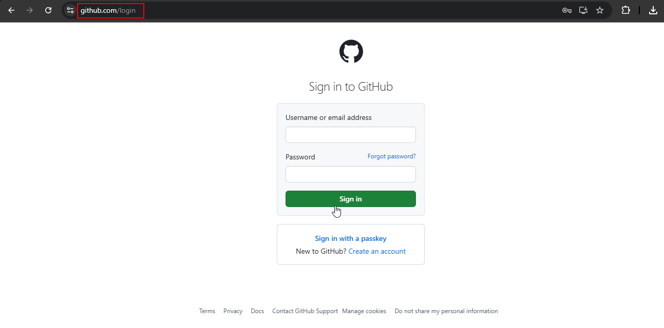
2. Fork the repository from the following URL:  
   **https://github.com/simplilearn10/SL-NodeJS-DevSecOps-Pipeline.git**

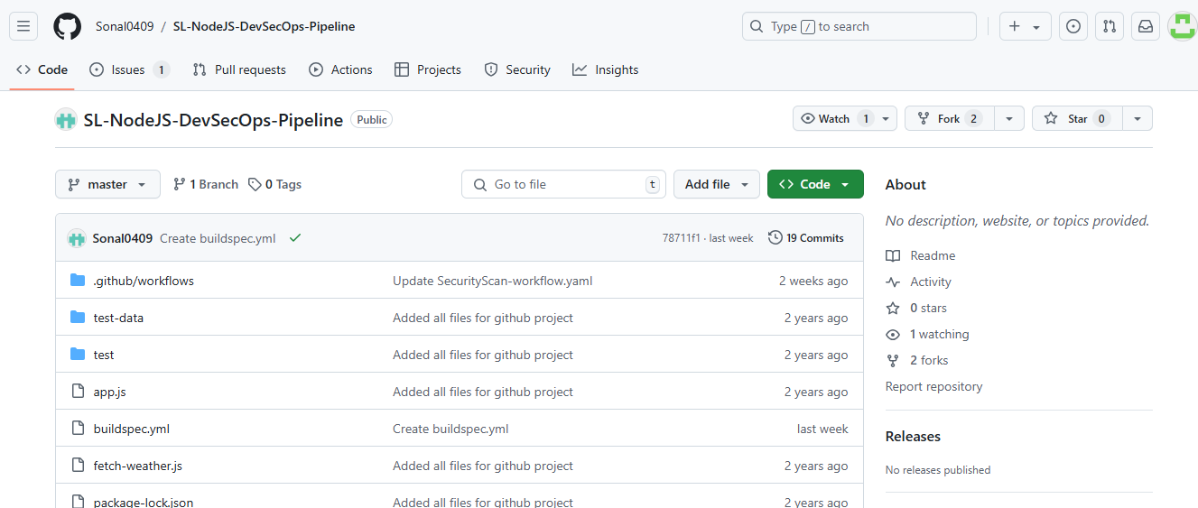

* 1. Click **Create fork** to complete the forking process   
       
     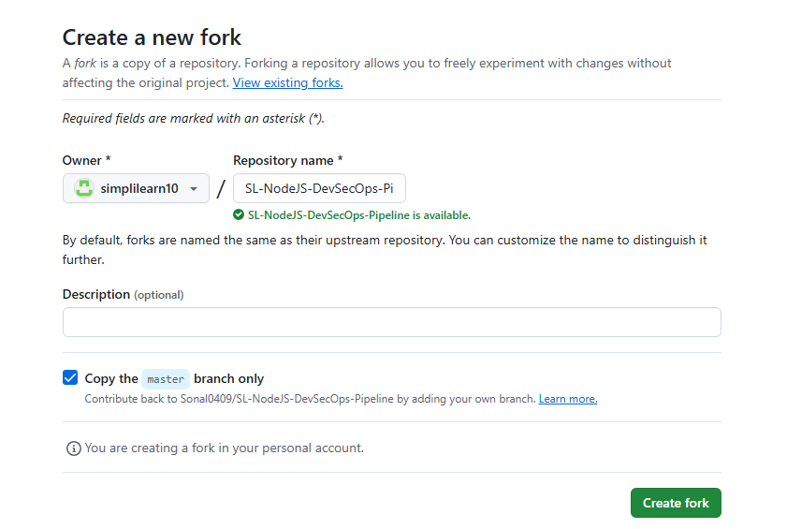
  2. Confirm if the repository is successfully forked   
     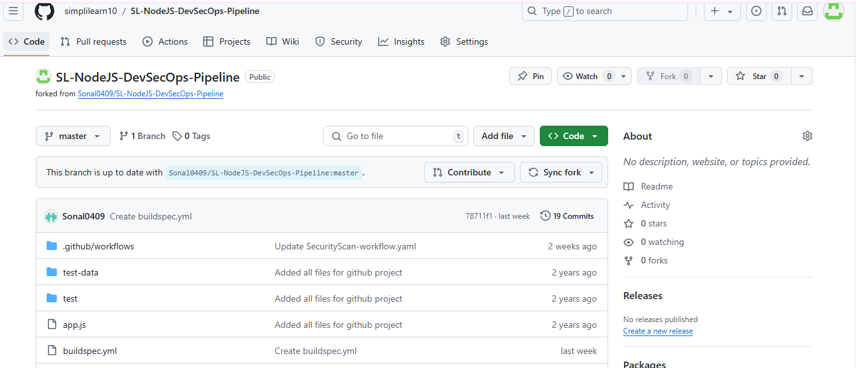

**Step 2: Connect the GitHub account with Snyk**

* 1. Navigate to the following URL and connect your GitHub account:  
     **https://app.snyk.io/login**  
     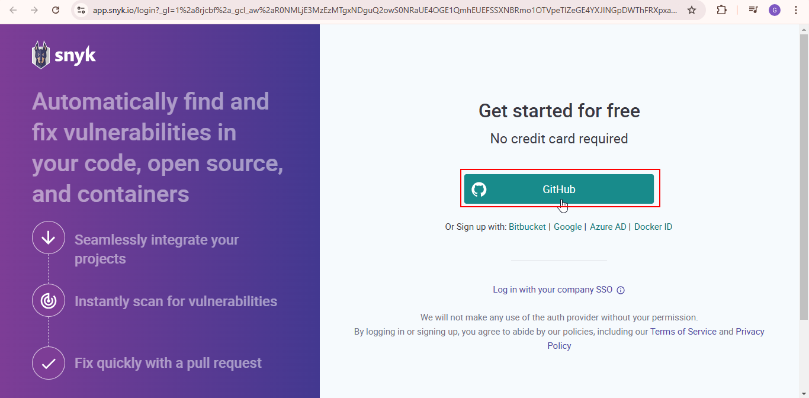
  2. Select **GitHub** as the integration method and click on **Next step**  
       
     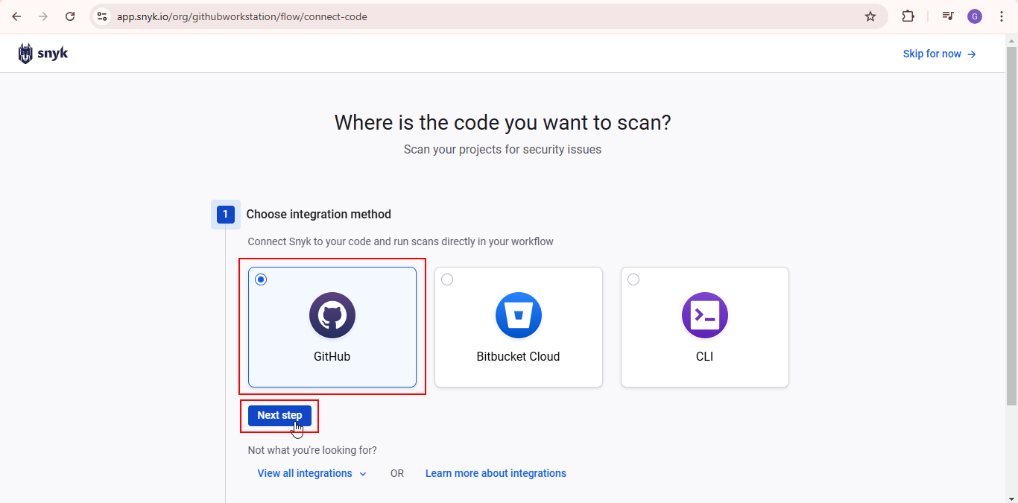
  3. Under access permissions, select **Private and public repositories** and proceed by clicking **Next step**

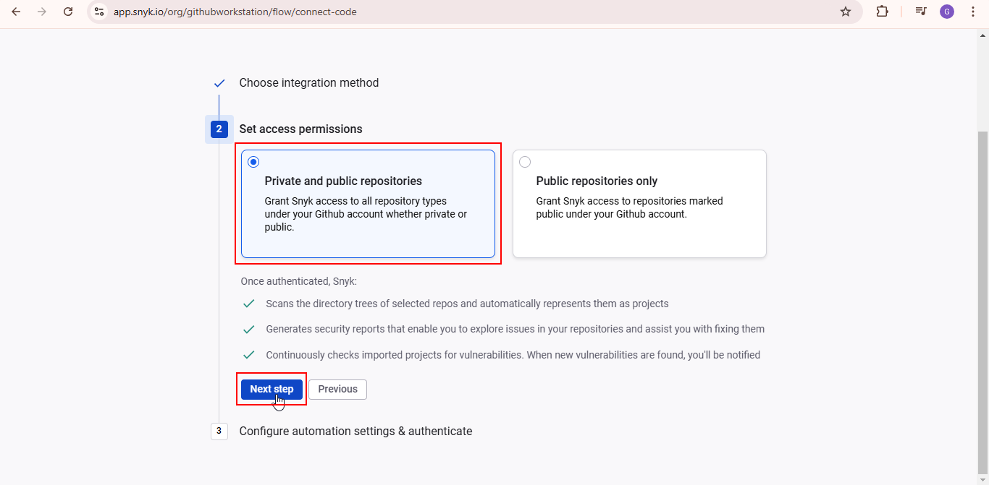

* 1. Enable the necessary features and click **Authenticate GitHub**  
       
     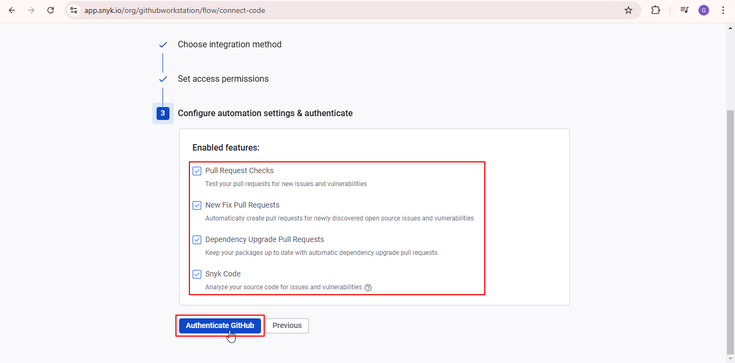

Confirm if your GitHub account is connected successfully  
  
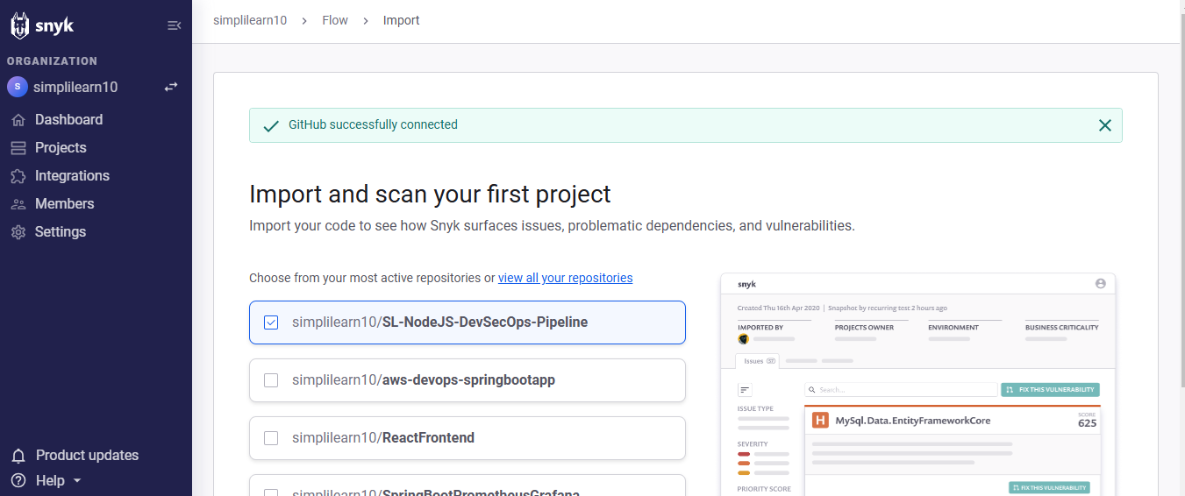

**Step 3: Generate and save an API token using Snyk**

1. Click on your account name at the bottom-left side and select **Account settings**

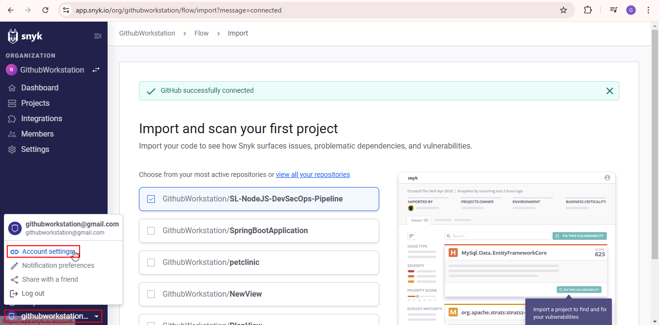

1. Under the **General** section, click **click to show** to view your authentication token

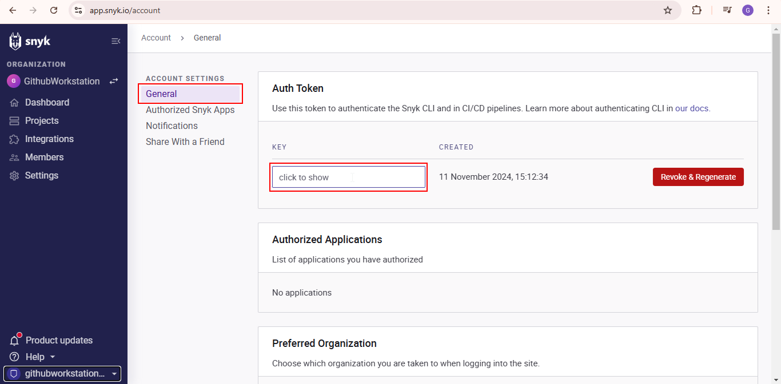

1. Copy the token and save it in a secure editor for use in subsequent steps  
     
   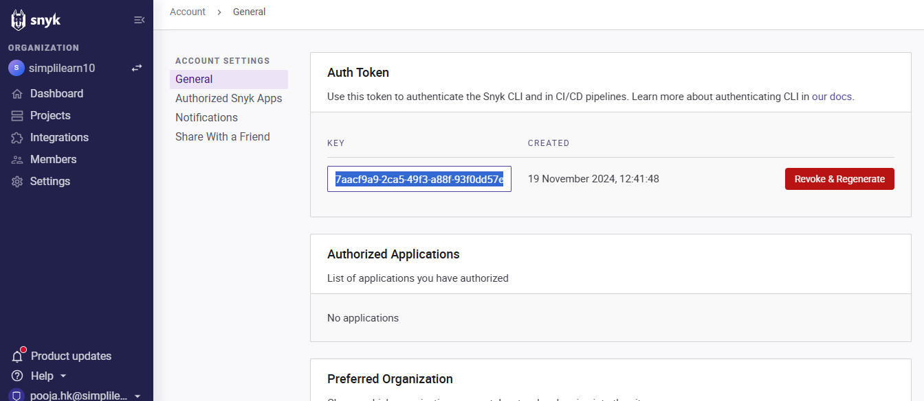

**Step 4: Configure the auth token in GitHub**

1. Open your forked repository in GitHub and locate the **buildspec.yml** file  
     
   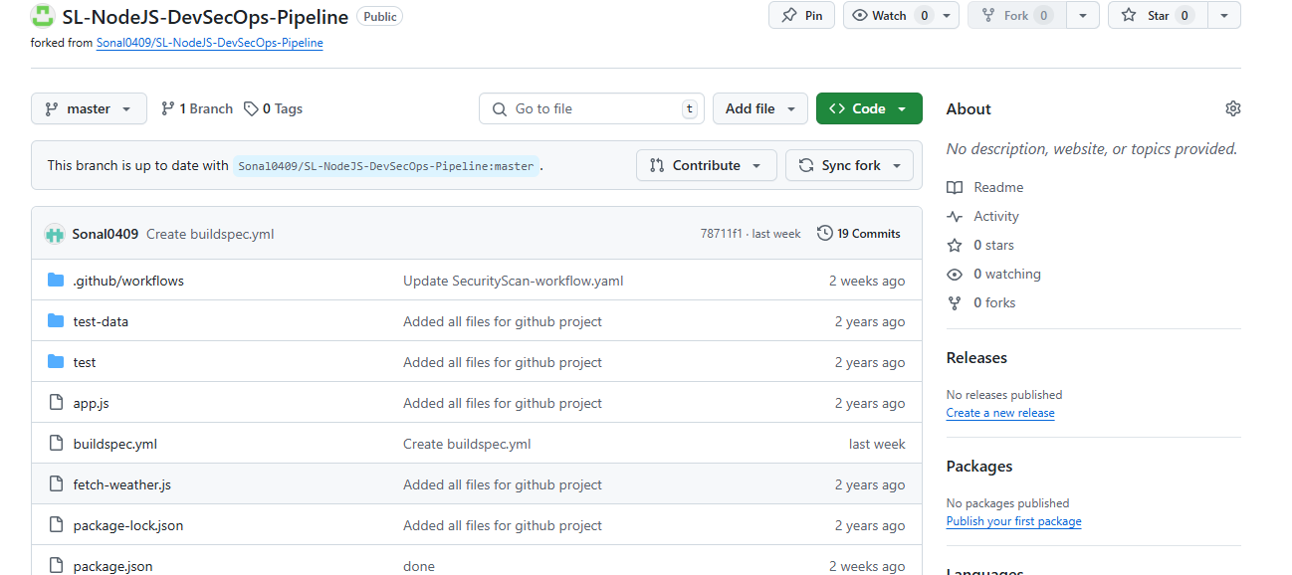
2. Add the saved auth token to line 14 in the file  
     
   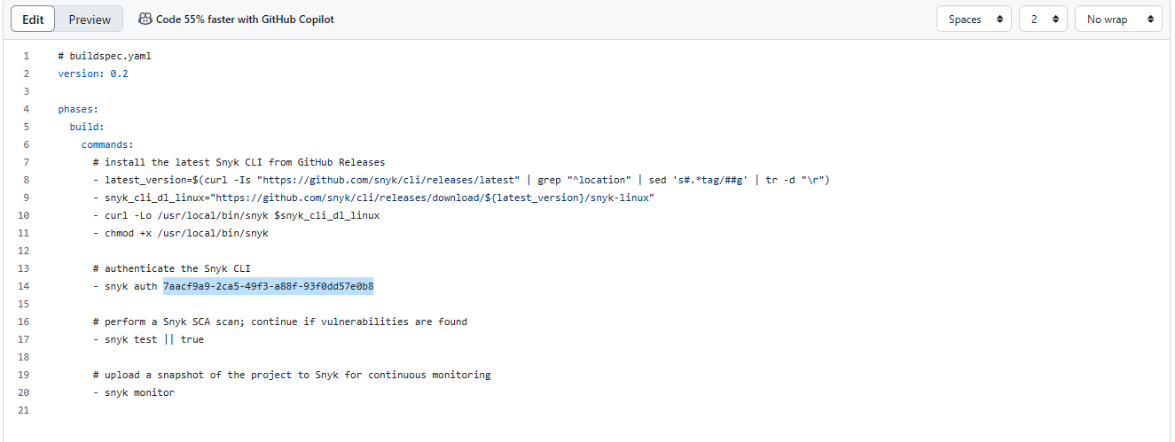
3. Commit the changes by clicking **Commit changes…**

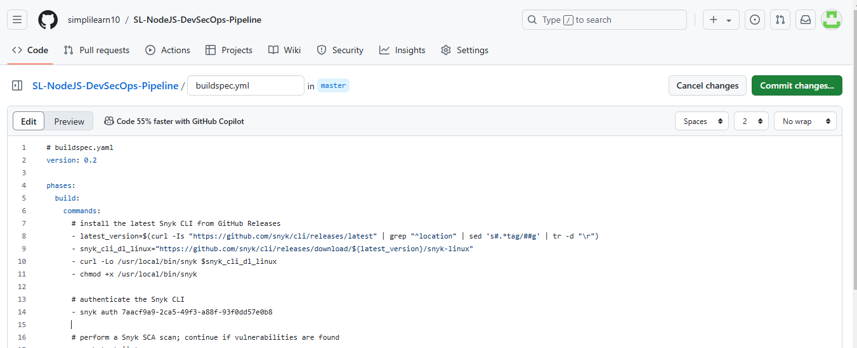

1. Click on **Commit changes**  
   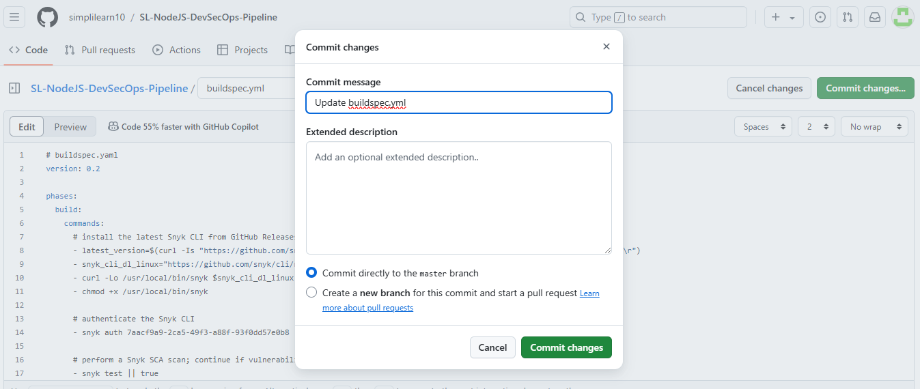

**Step 5: Create an AWS CodePipeline**

1. Log in to the AWS Management Console and navigate to **CodePipeline**  
     
   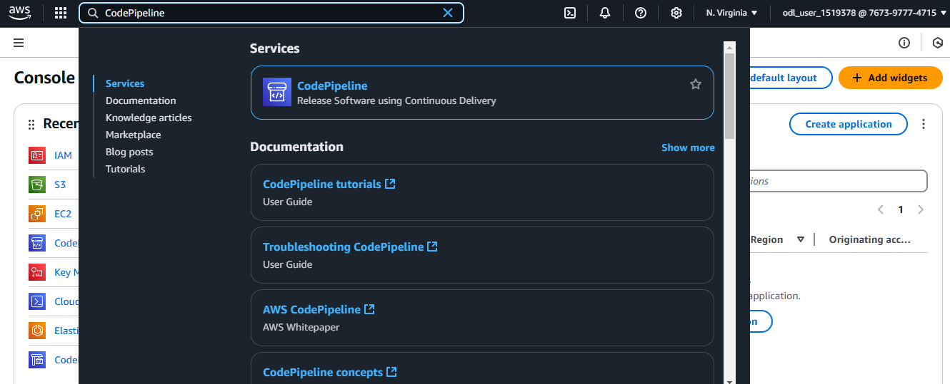
2. Click **Create pipeline**  
     
   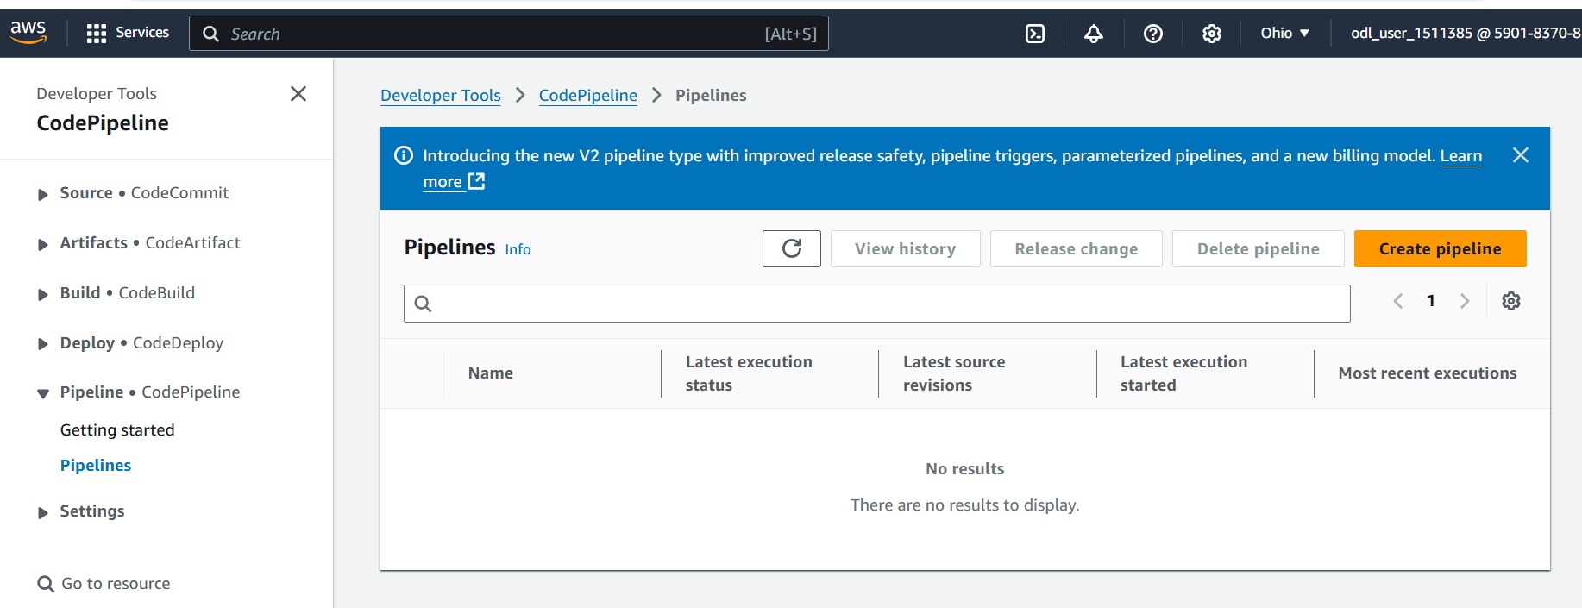
3. Choose **Build custom pipeline** and click **Next**  
     
   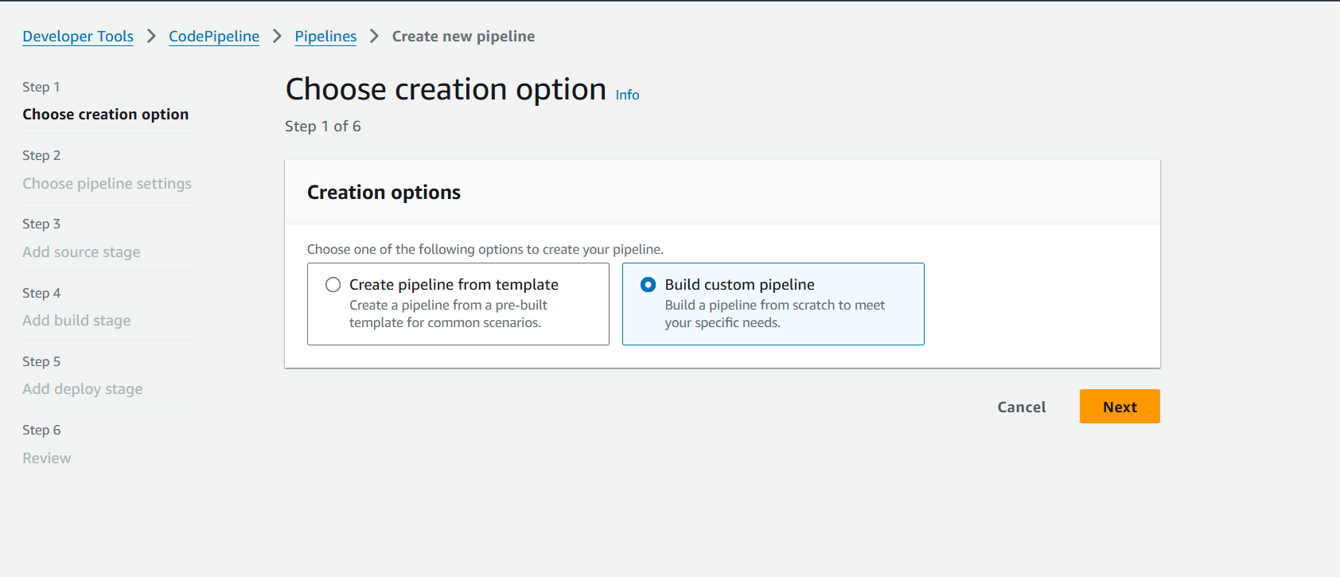
4. Provide a name for the pipeline  
     
   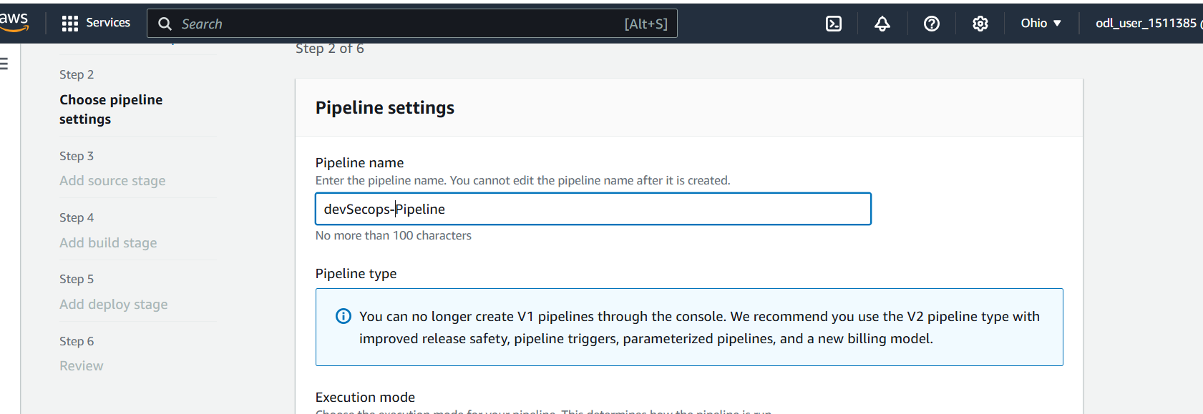
5. Select **Queued (Pipeline type V2 required)** as the execution mode 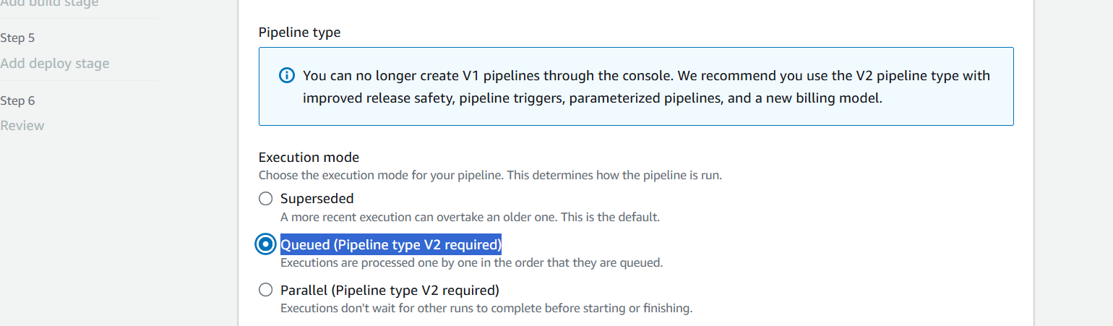
6. Choose **New service role**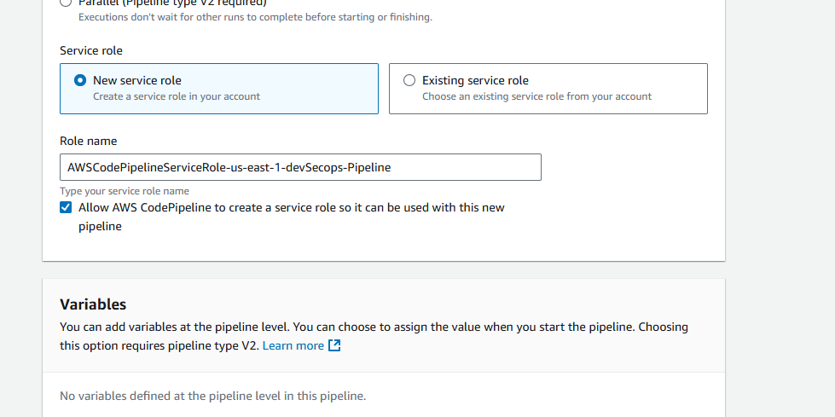
7. Scroll down and click **Next**  
     
   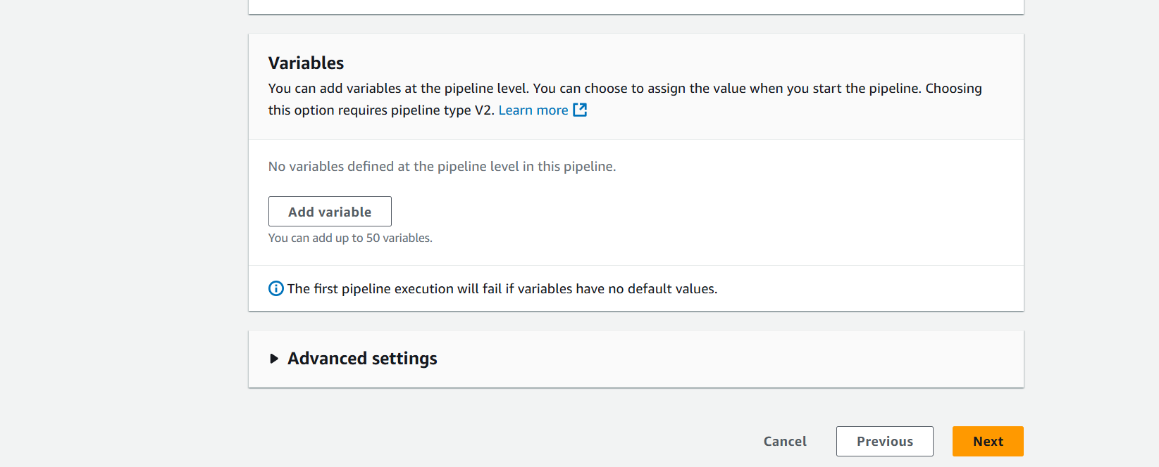
8. For the source provider, select **GitHub (via OAuth app)** and connect GitHub  
   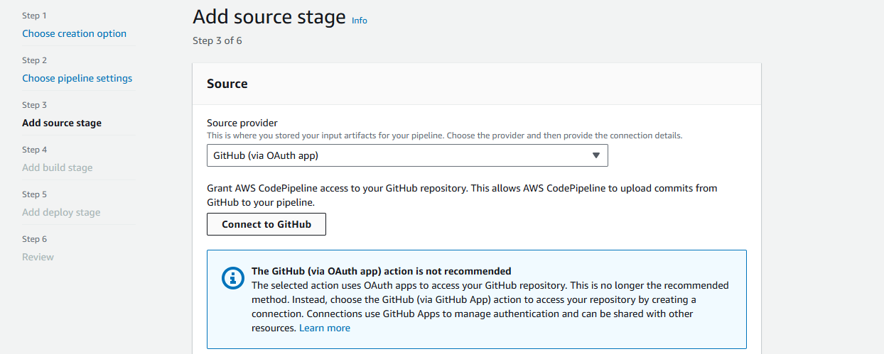
9. Authorize the connection by clicking **Confirm**  
     
   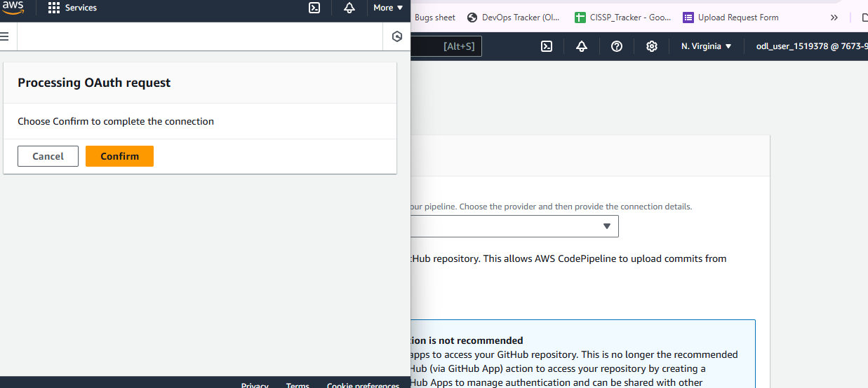

Confirm if the action is configuration successfully with the provider.   
  
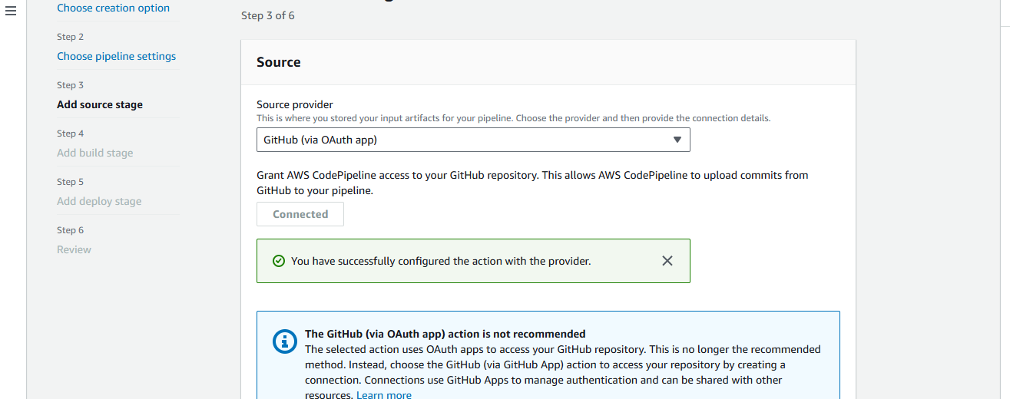

1. Select the repository  
     
   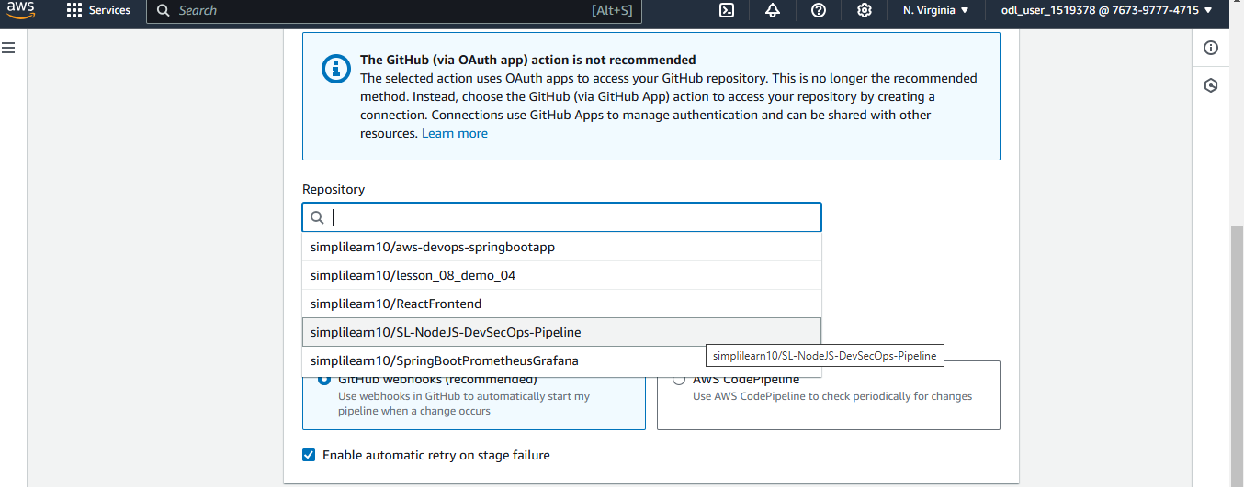
2. Select the branch to **master** and click **Next**  
     
   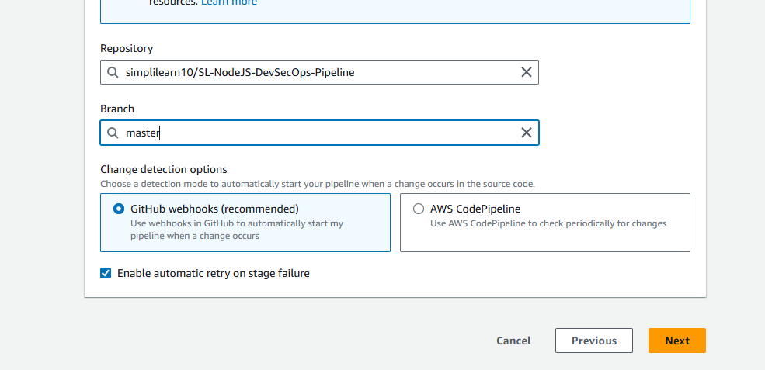
3. In the Build provider, choose **Other build providers** and then select **AWS CodeBuild** as the provider

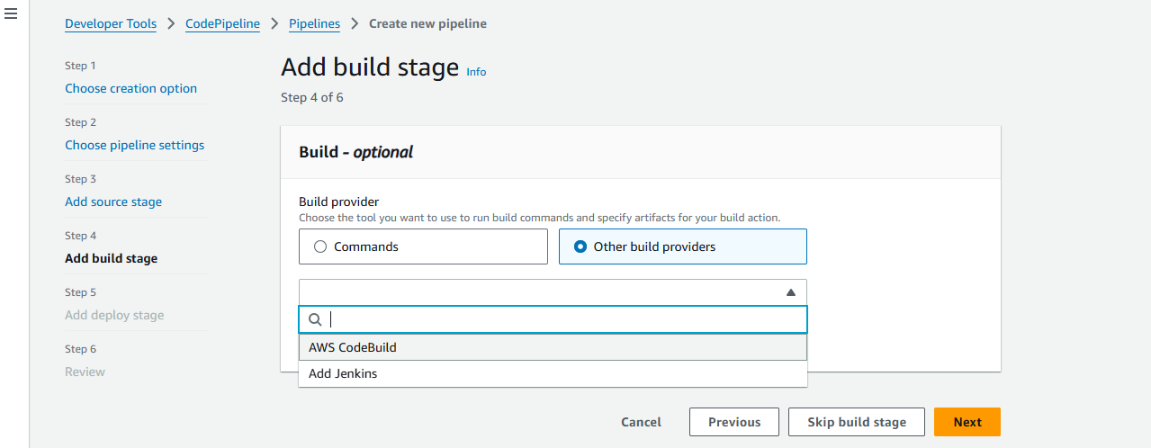

1. Click **Create project**  
     
   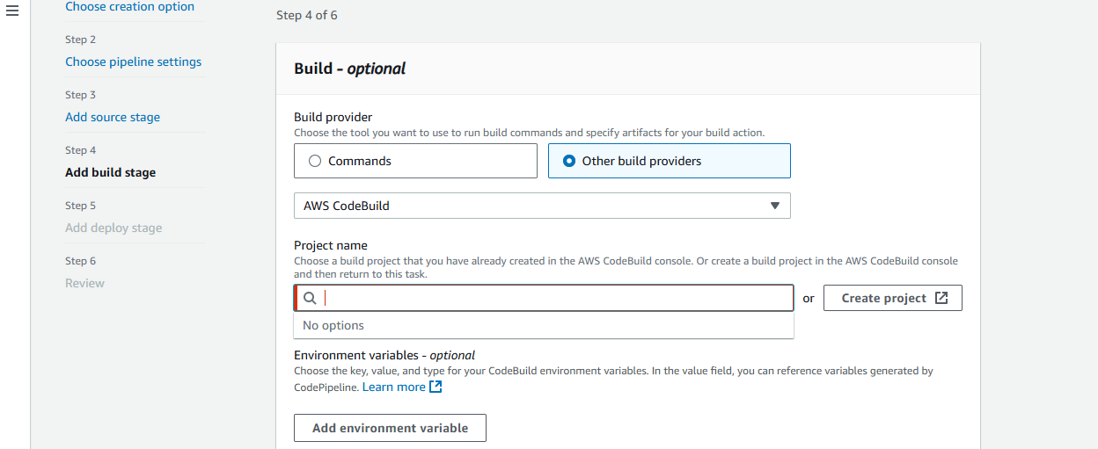
2. Enter the **Project name** as **BuildNodeJsCode**  
     
   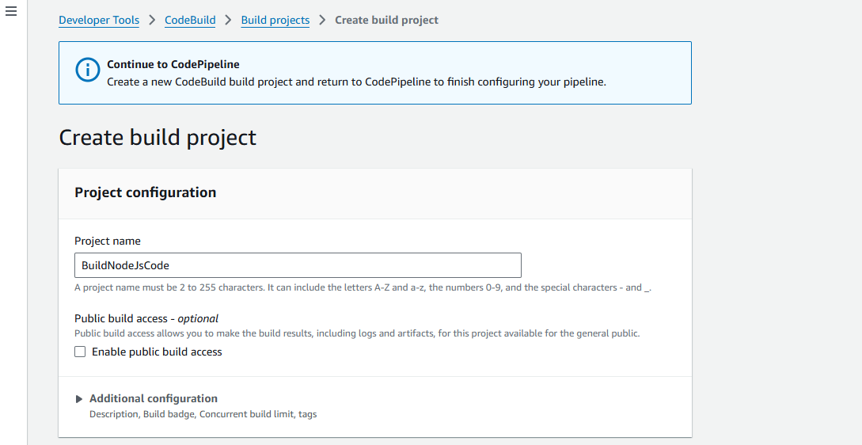
3. Keep the settings to default

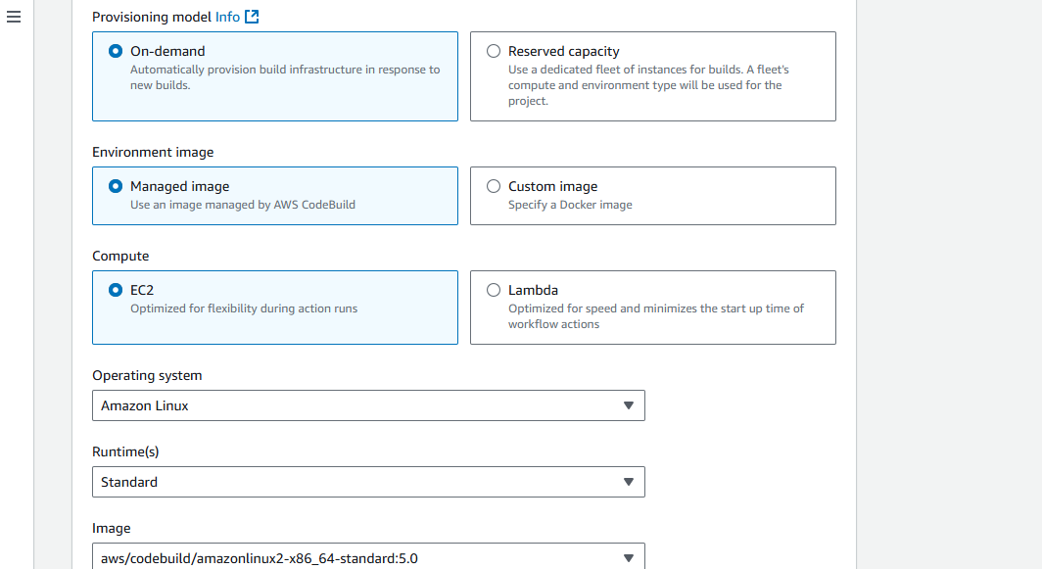

1. In the **Buildspec** section, select **Insert build commands** and enter the build command as **npm run**  
     
   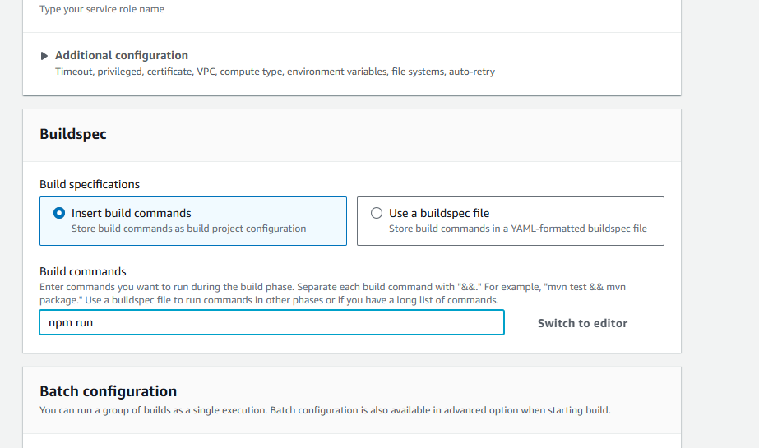
2. Click **Continue to CodePipeline**  
     
   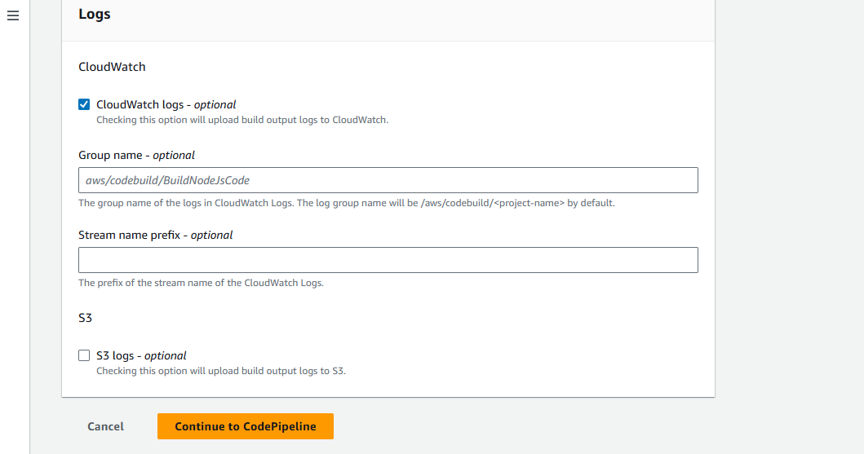
3. Click **Leave**  
     
   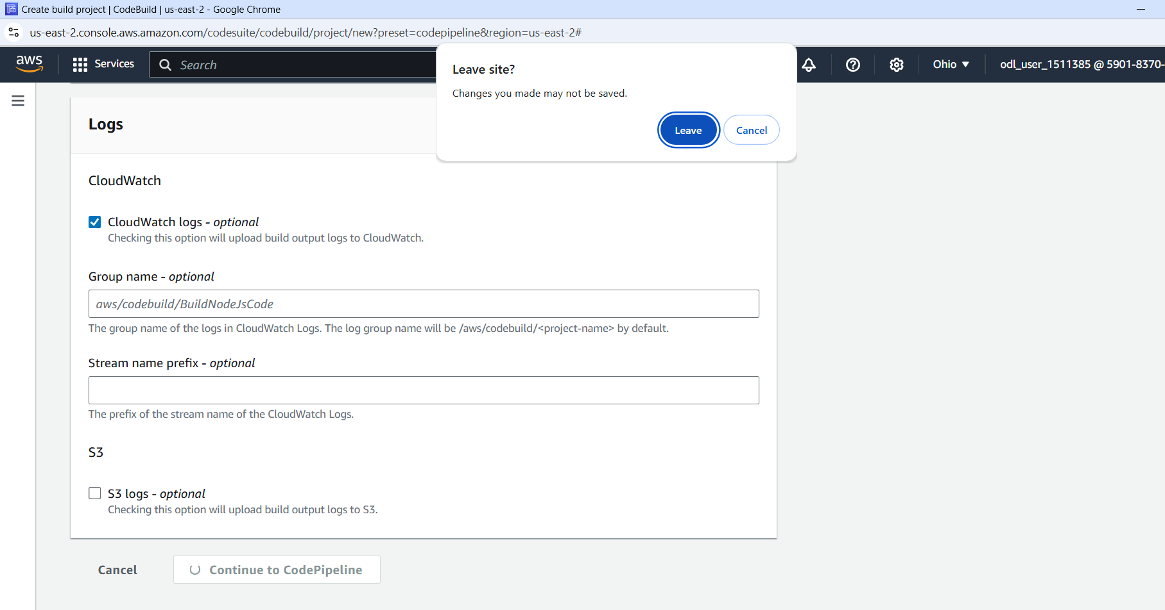

Confirm if BuildNodeJsCode in CodeBuild is created successfully  
  
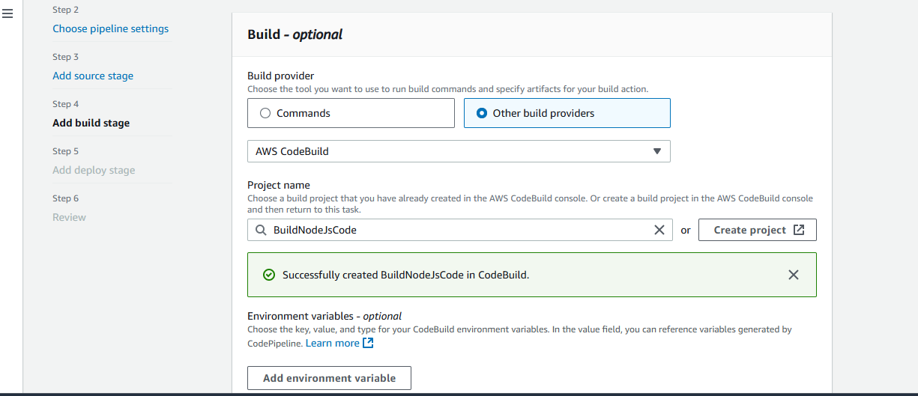

1. Choose the Input artifacts as **SourceArtifact** and click **Next**  
     
   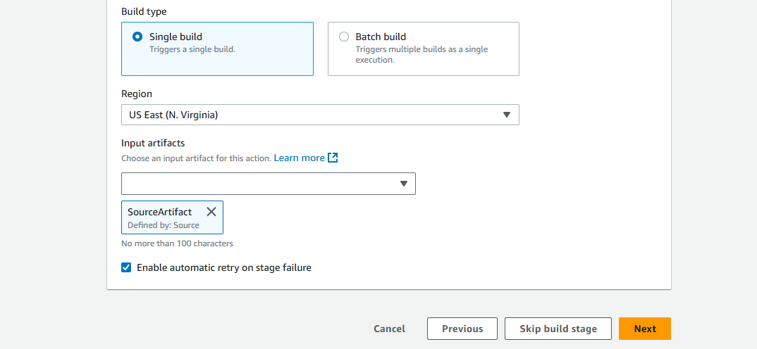
2. Click **Skip deploy stage**  
     
   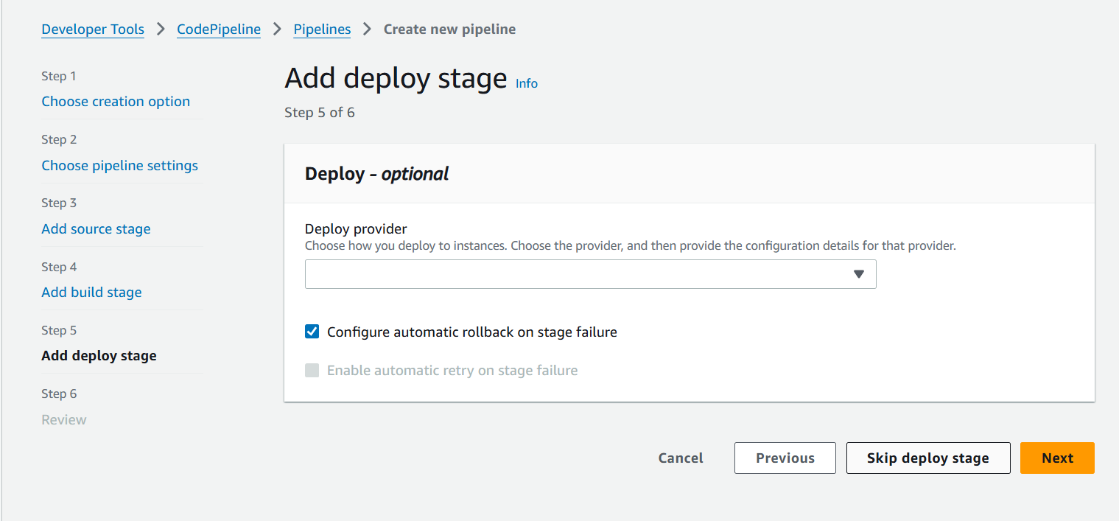
3. Click **Skip**  
     
   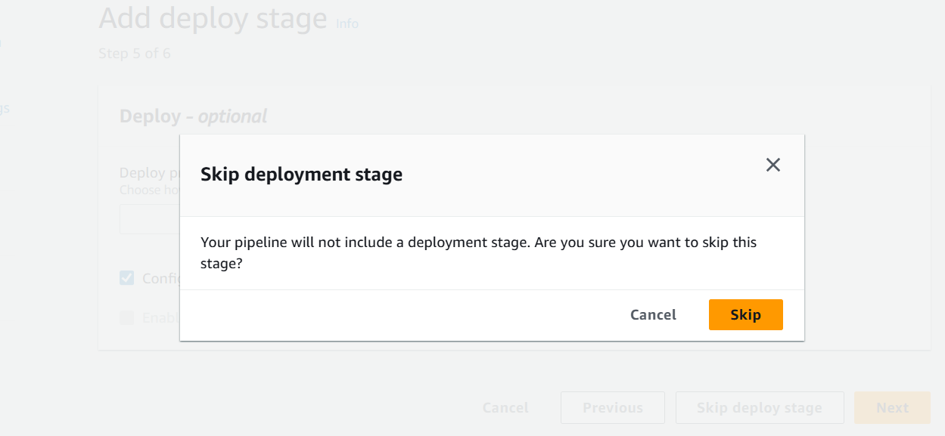
4. Click **Create pipeline**  
     
   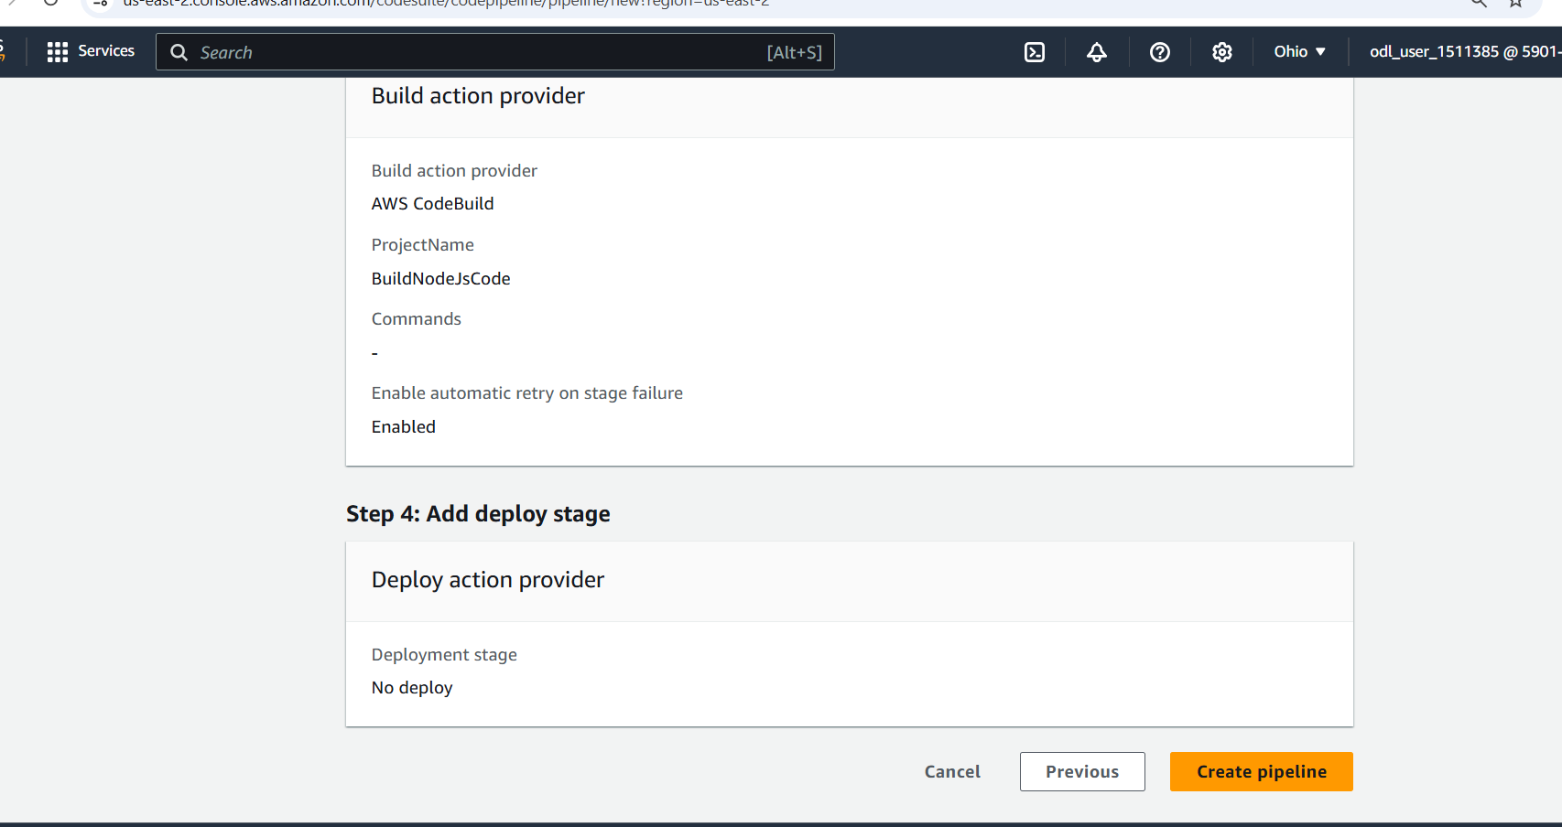

Confirm if the CodePipeline is created successfully  
  
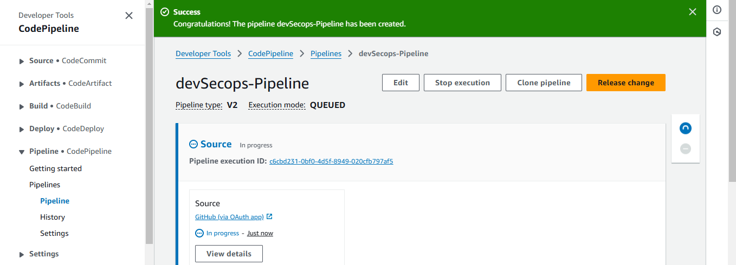

**Step 6: Implement SCA and SAST scans**

1. In the **AWS Management Console**, search for **CodeBuild** and select it  
     
   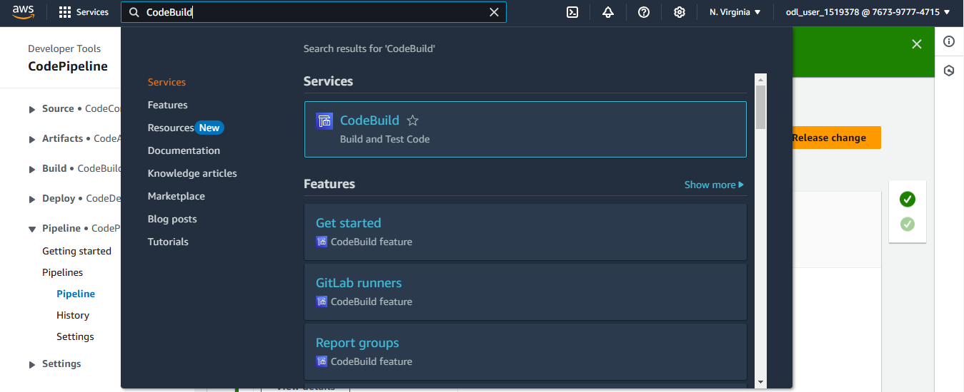
2. Click **Create project**  
     
   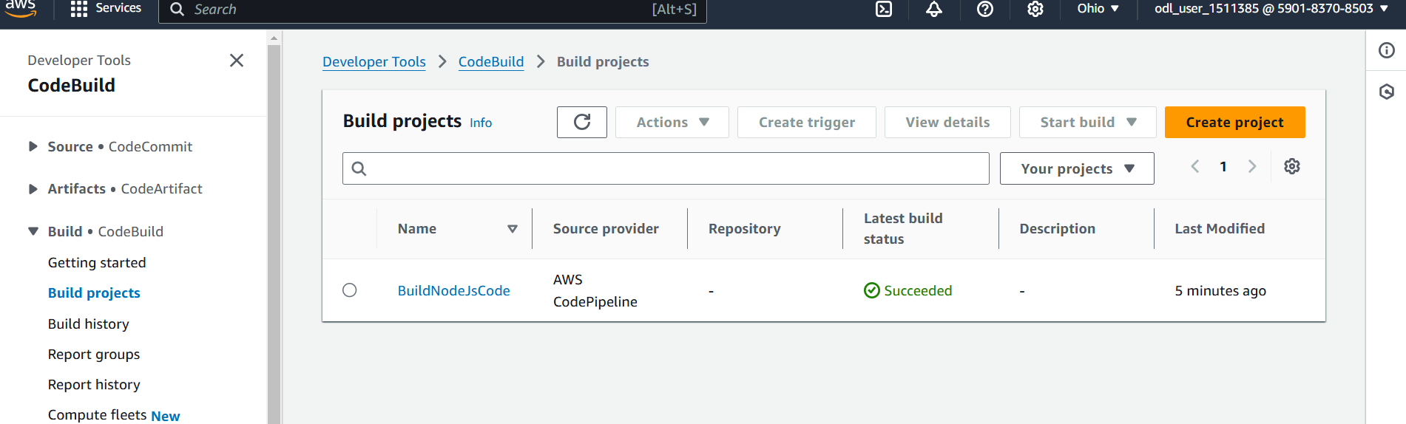
3. Provide a project name   
   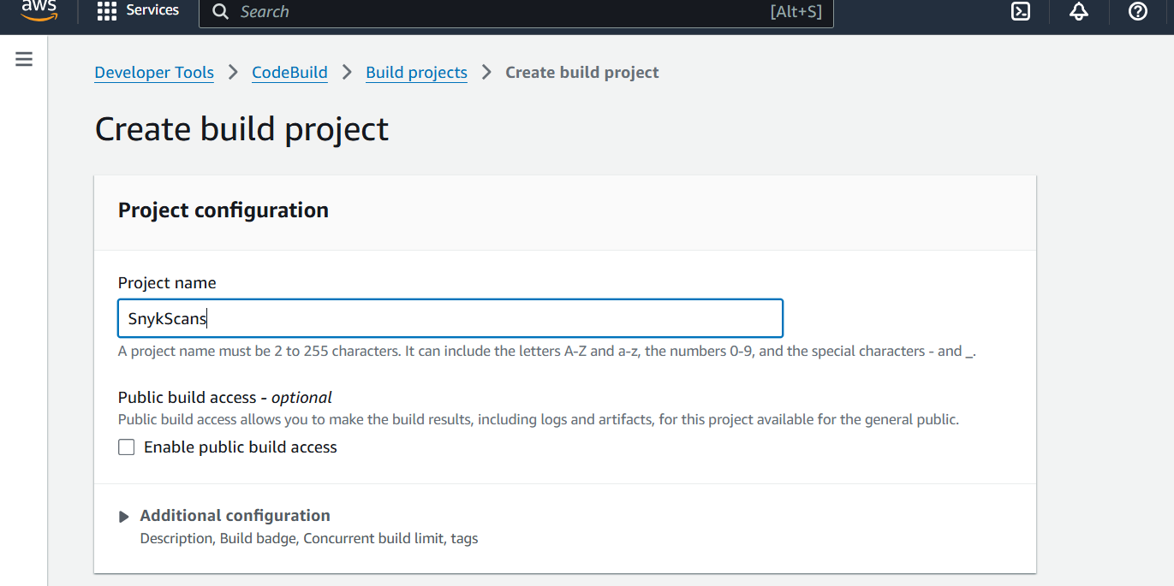
4. Choose **GitHub** as the Source provider  
     
   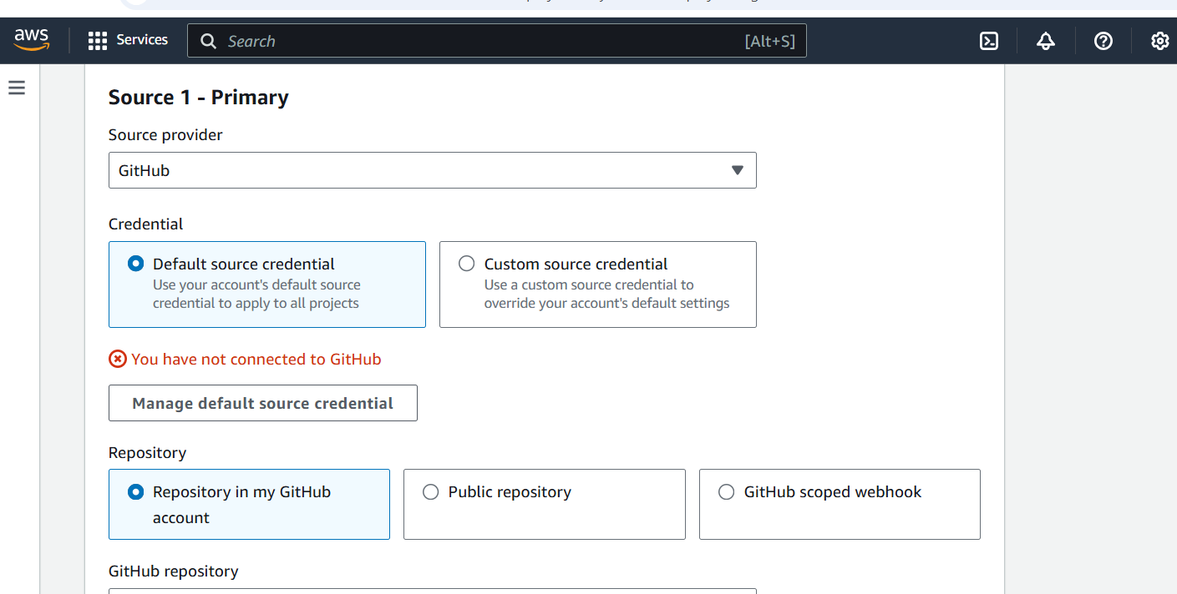
5. Choose **Personal access token** as Credential type  
     
   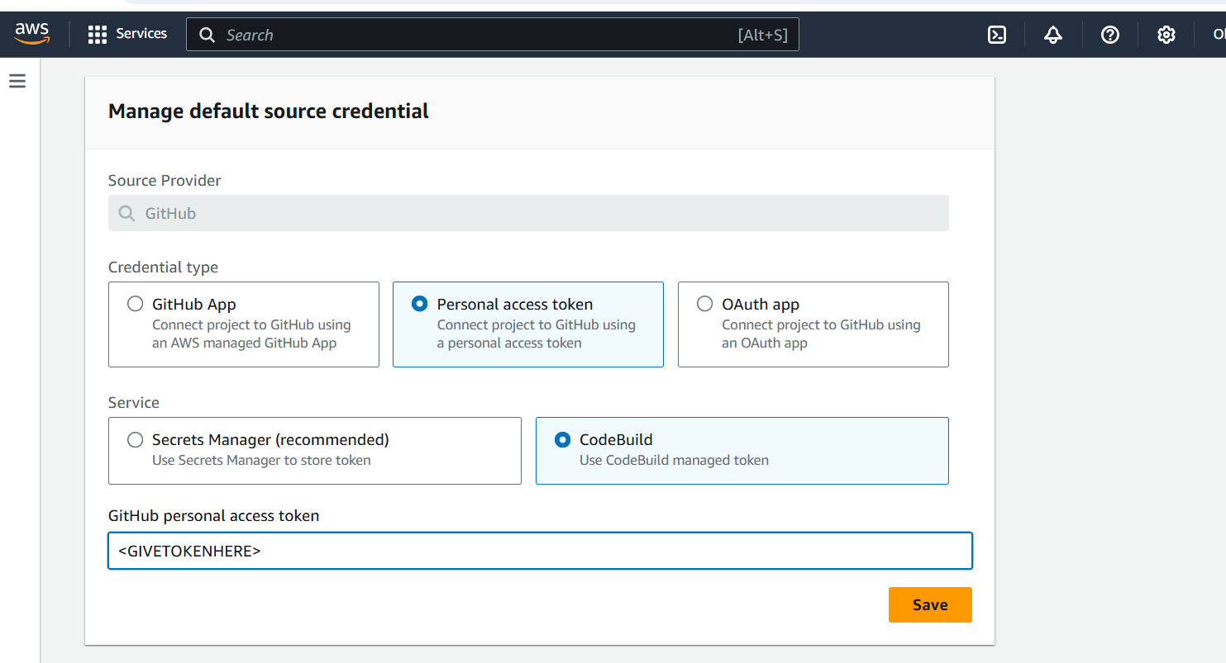
6. Provide the GitHub token key and click on **Save**  
     
   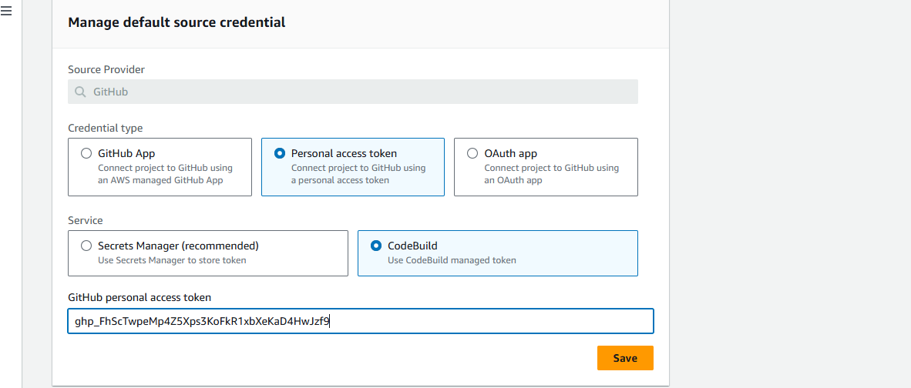
7. Select **Repository in my GitHub** account  
     
   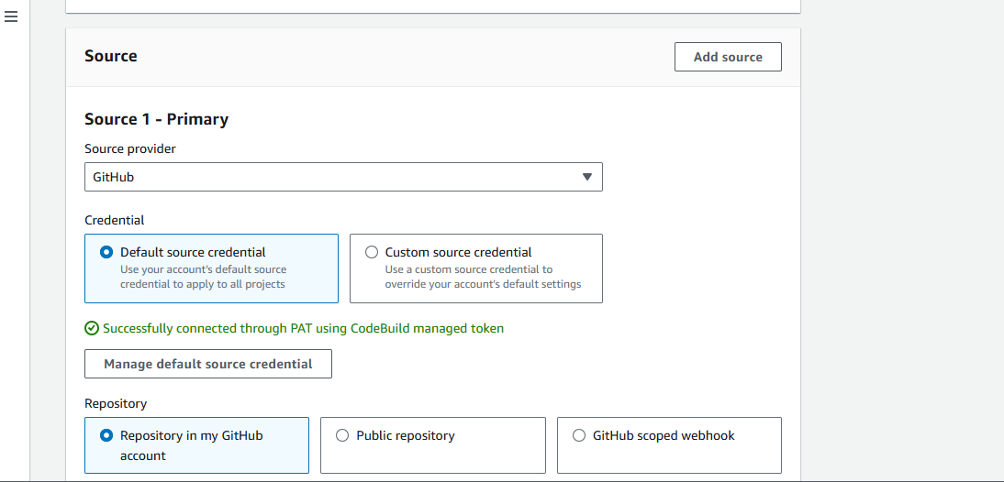
8. Navigate to the GitHub and copy the repository URL   
   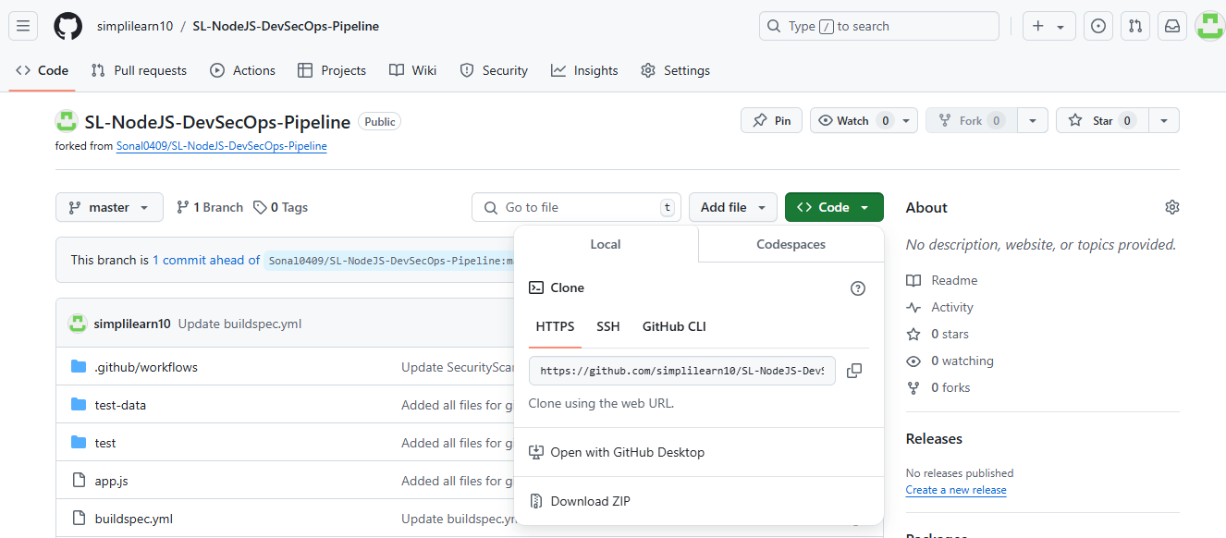
9. Paste the repository URL  
     
   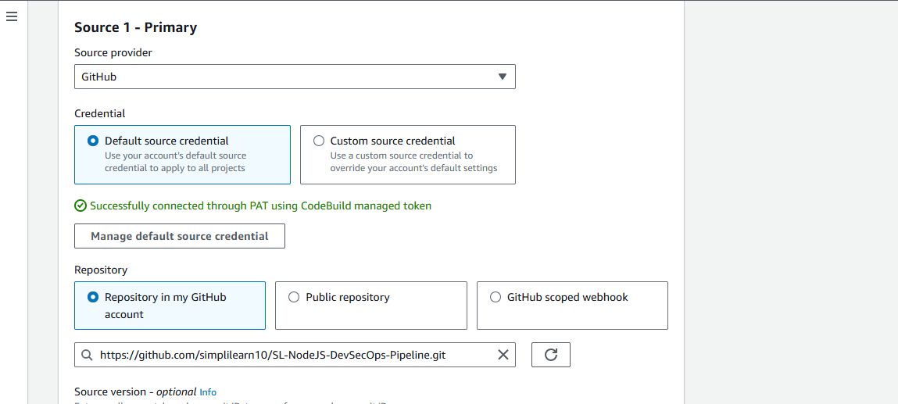
10. Select **Use a buildspec file** and then provide Buildspec name as **buildspec.yml**  
      
    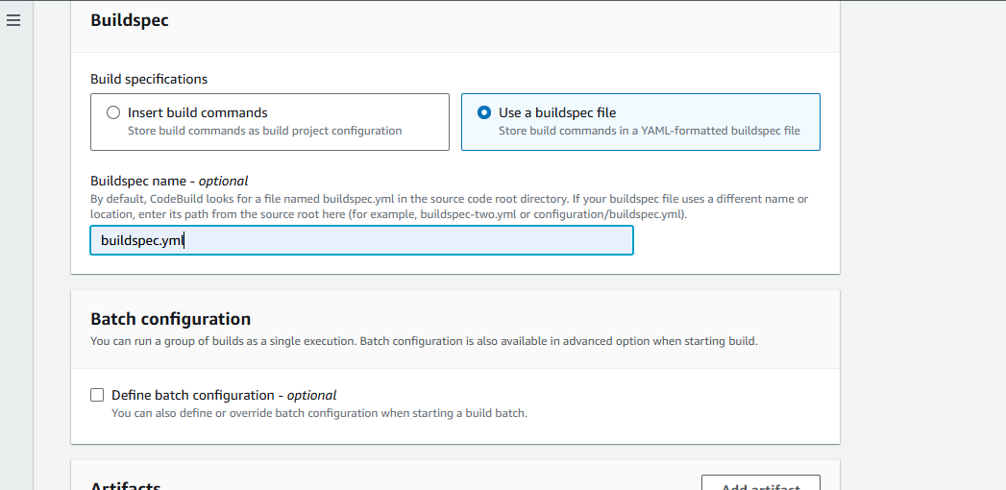
11. Select **Amazon S3** as the type of artifact type and then choose the appropriate bucket   
      
    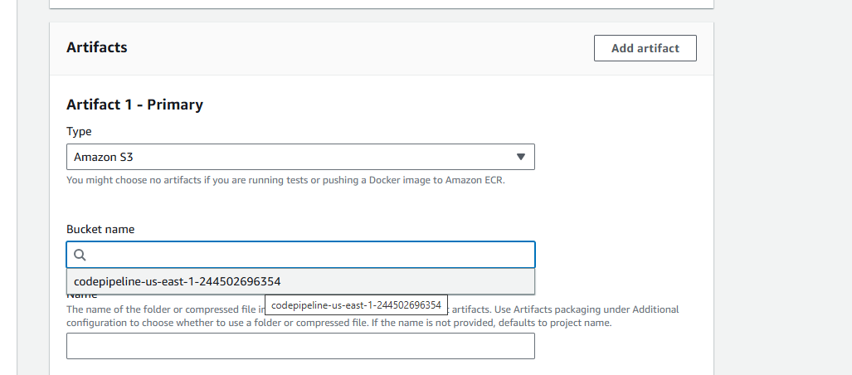
12. Give a name to the folder or compressed file that will contain the output artifacts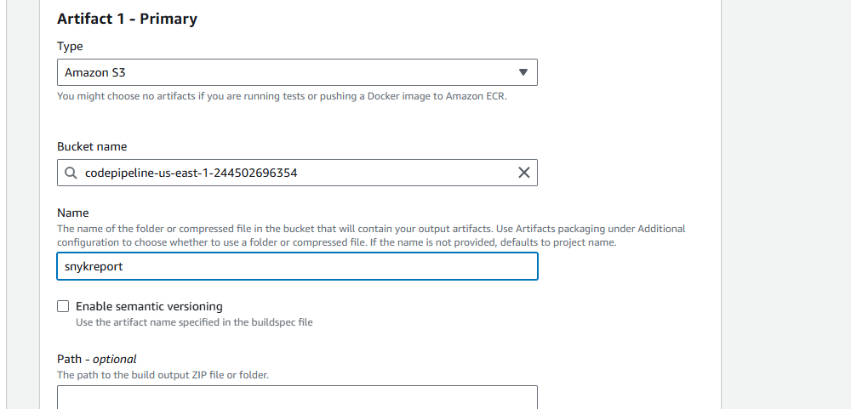
13. Click **Create build project**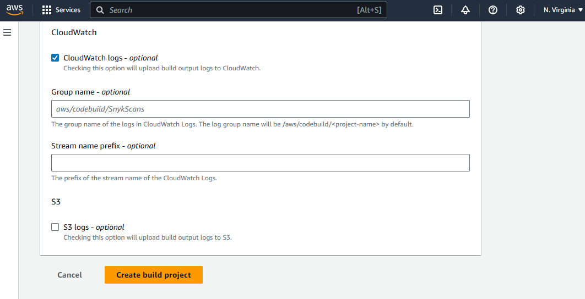

Confirm if the project creation is successful  
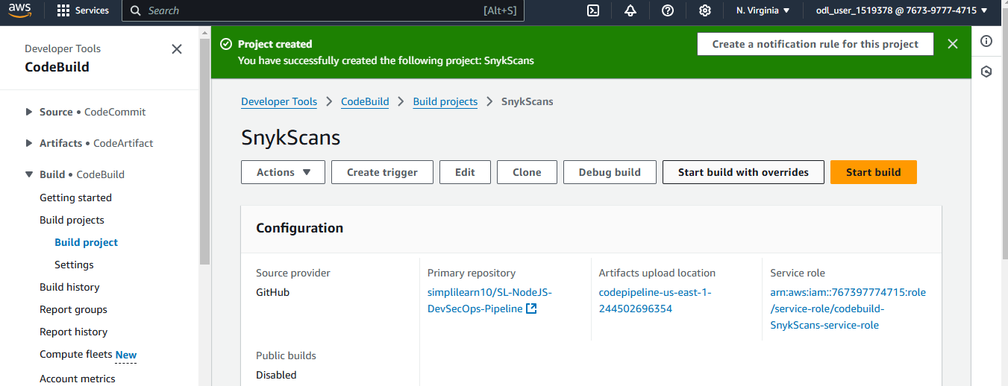

1. Click **Start build**Confirm if the build is successful  
    **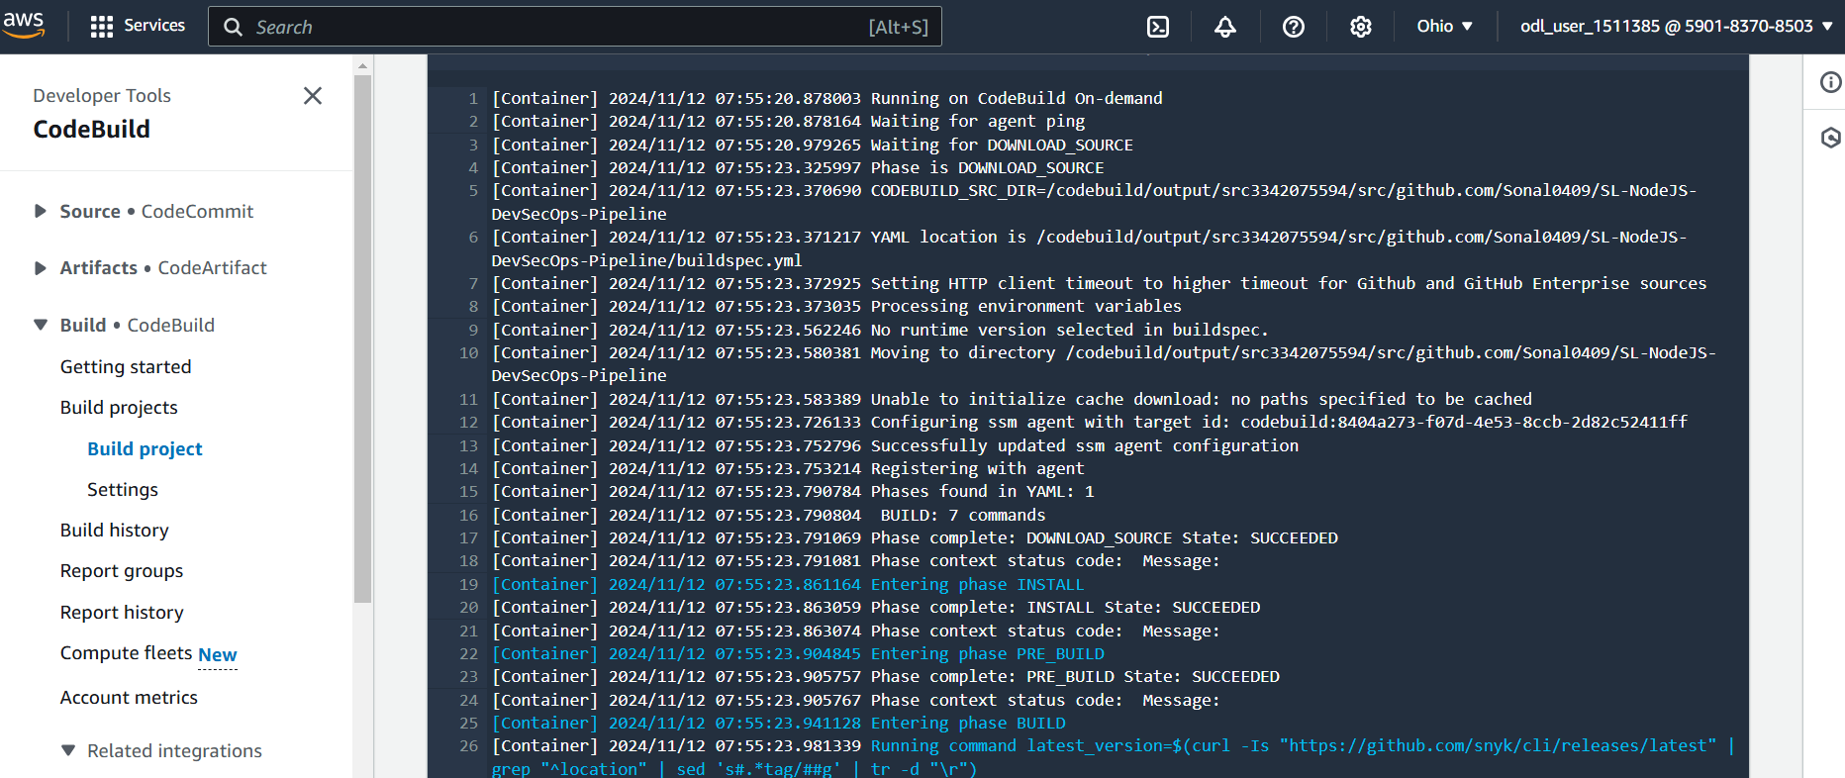  
     
   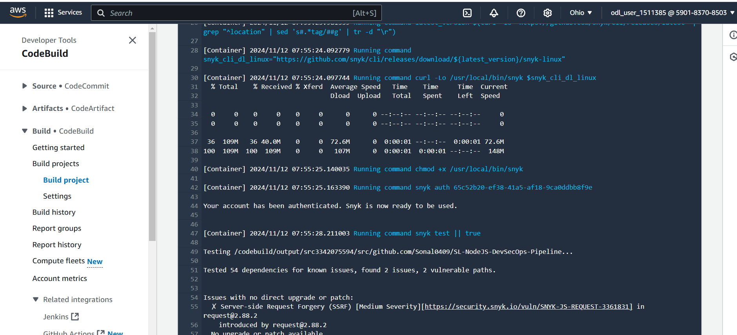**

**Step 7: Perform DAST scans using OWASP ZAP**

1. Search for CodePipeline in the search bar and click the service  
     
   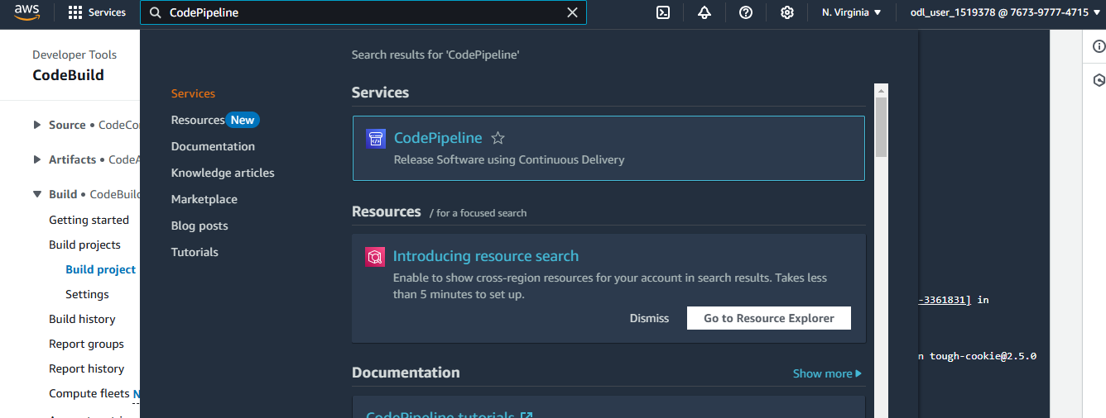
2. Select the created pipeline  
     
   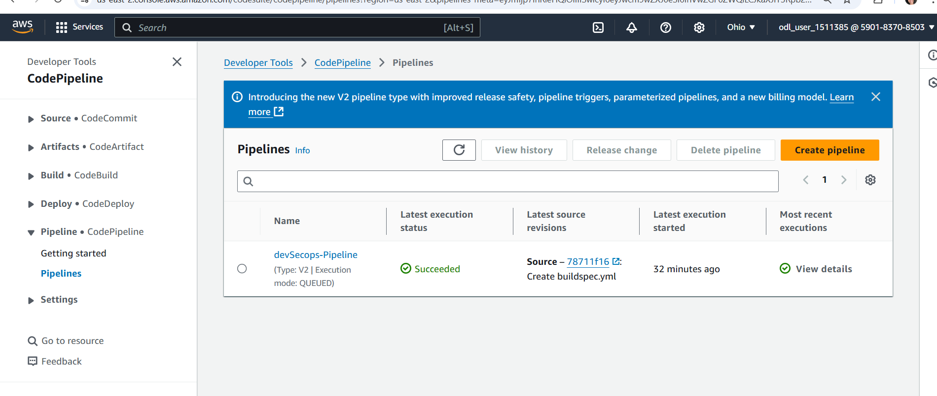
3. Scroll down to the bottom  
     
   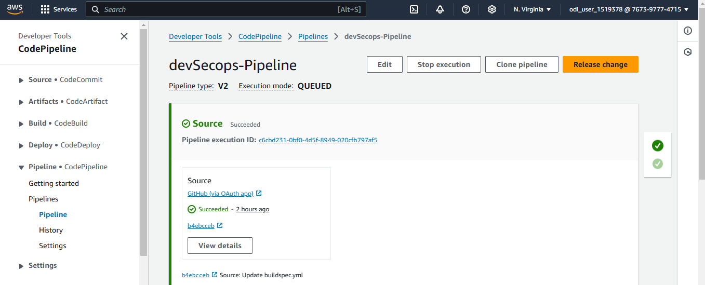
4. Click **Add stage**  
     
   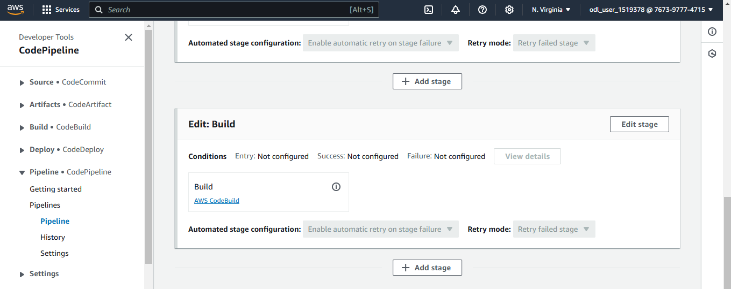
5. Provide a name for the stage and click **Add Stage**  
     
   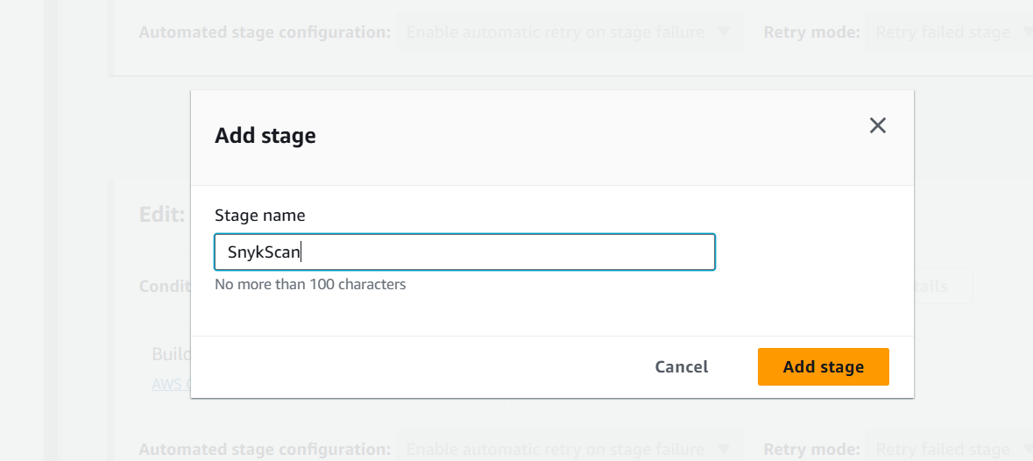
6. Click **Add action group**  
     
   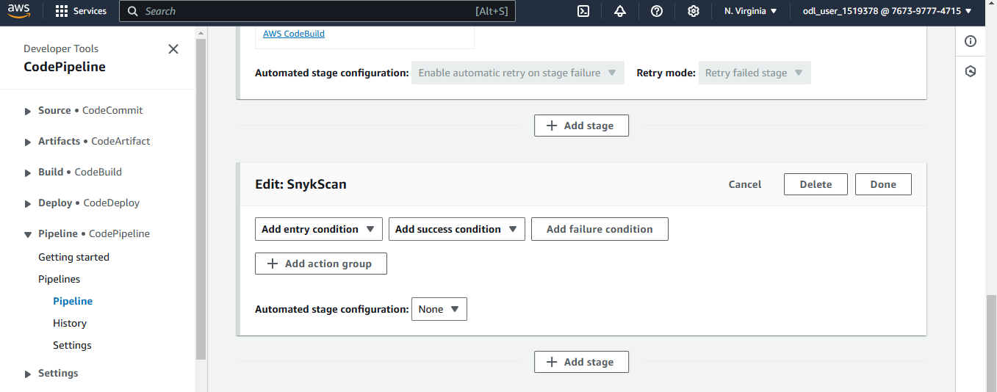
7. Give a name to the Action and choose **AWS CodeBuild** as the Action provider  
     
   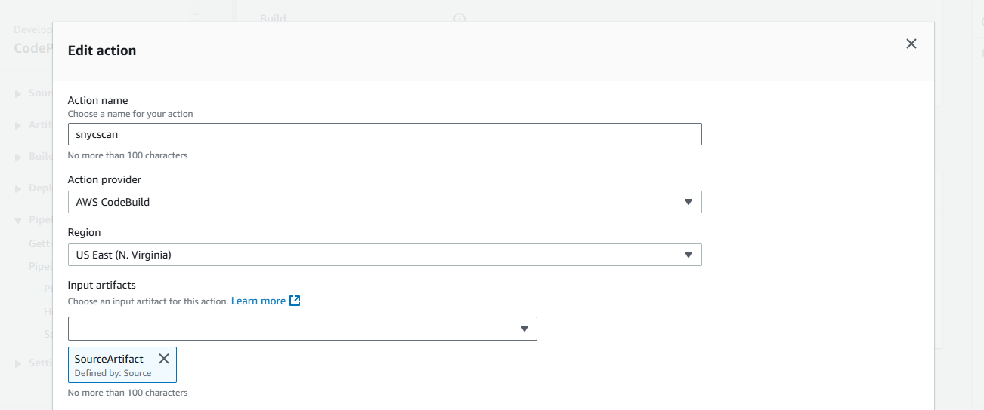
8. Give a name to the project and click **Done**  
     
   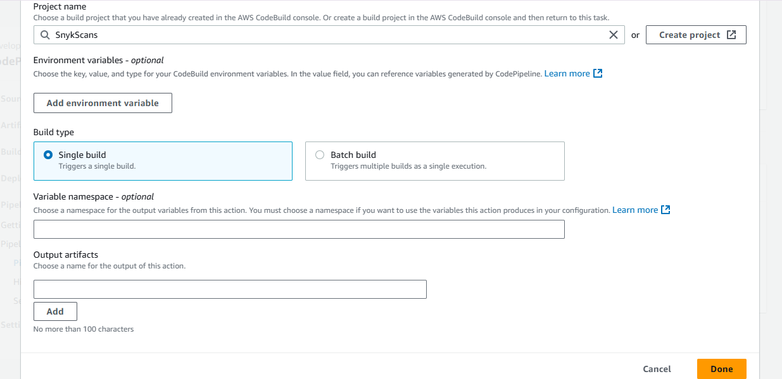
9. Scroll up and click **Save**  
     
   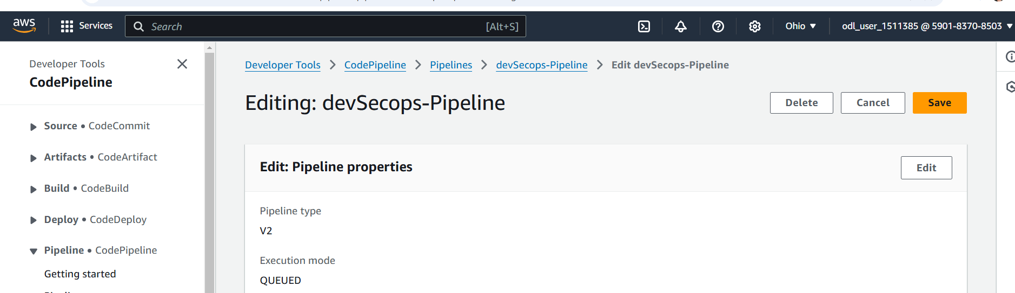

Confirm if the action is successful  
  
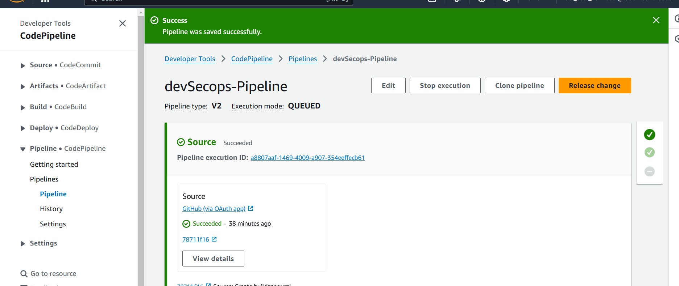

**Step 8: Review results in Amazon S3**

1. Search S3 in the search bar and click the service  
     
   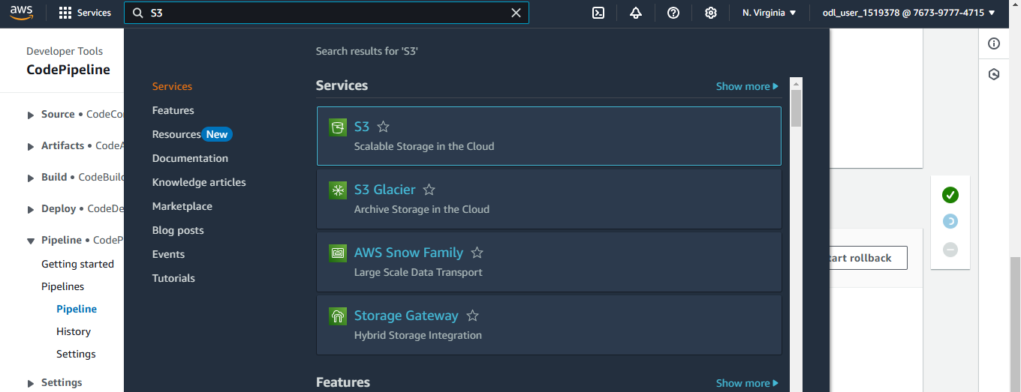
2. Locate the bucket associated with the CodePipeline artifacts  
     
   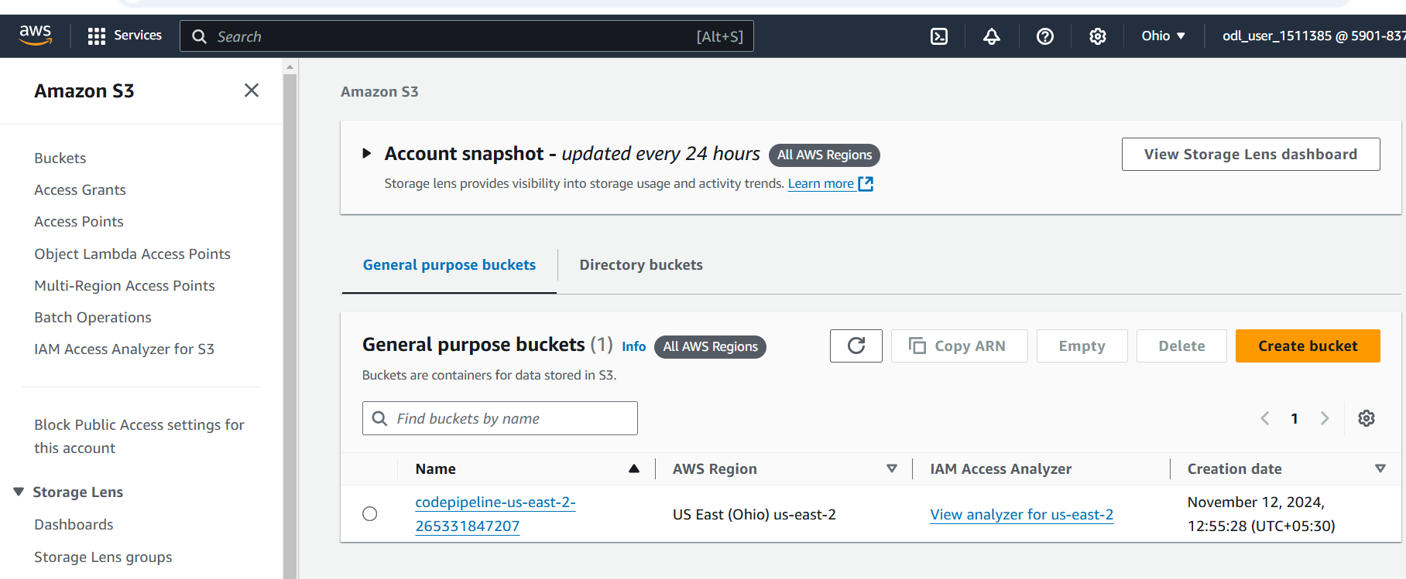
3. Open the generated object and review the sorted files  
     
   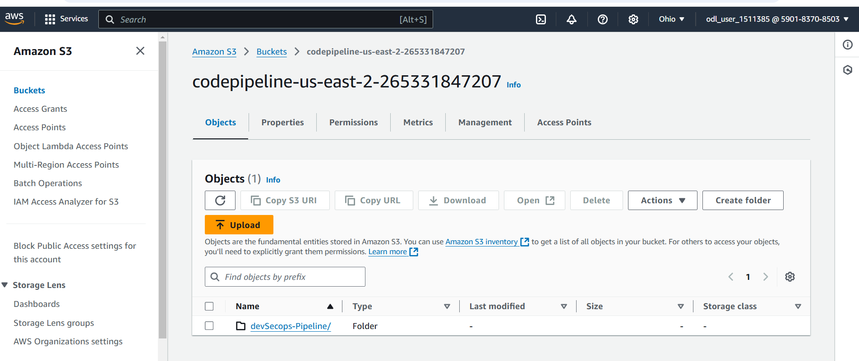
4. Click on the file created  
     
   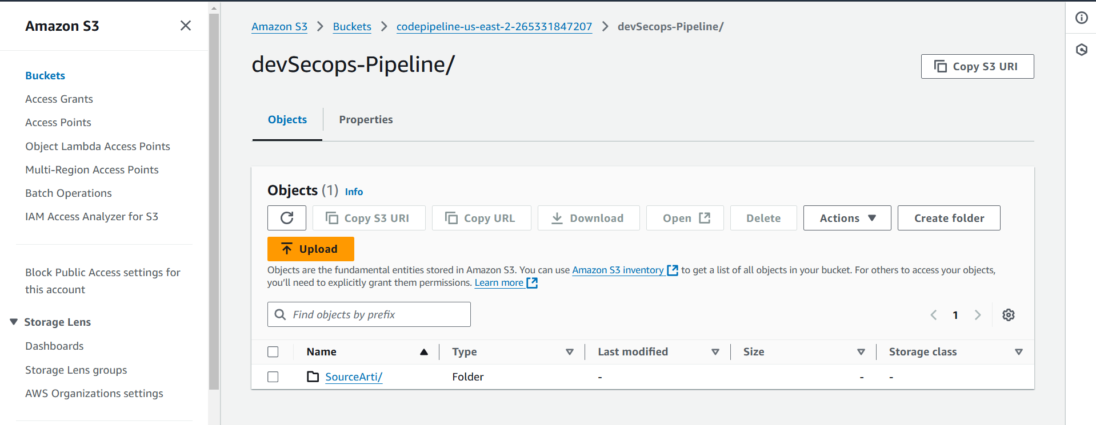

Analyze the ZIP files or other outputs  
  
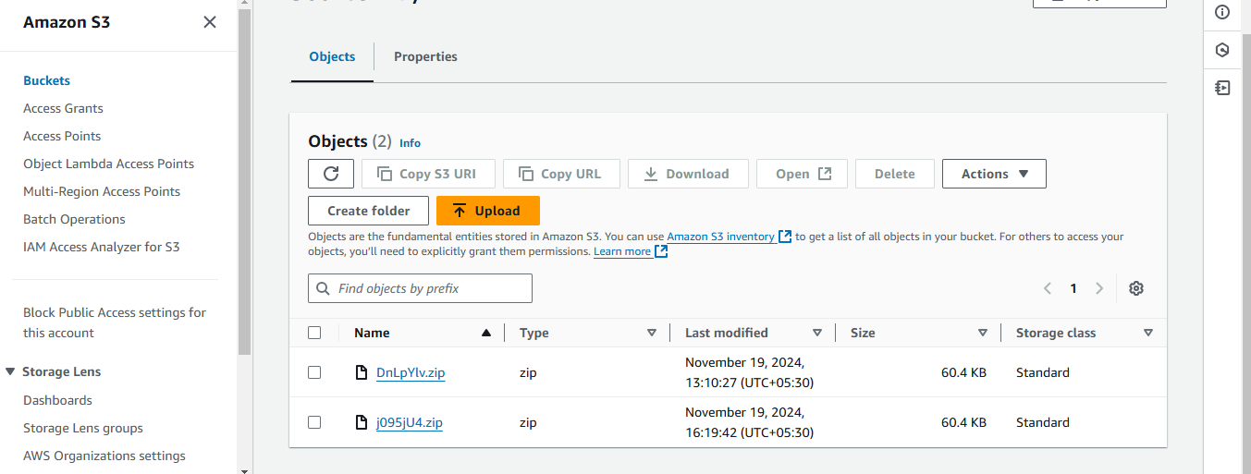

**Step 9: Finalize and deploy the changes**

1. Search for CodeBuild and click the service  
     
   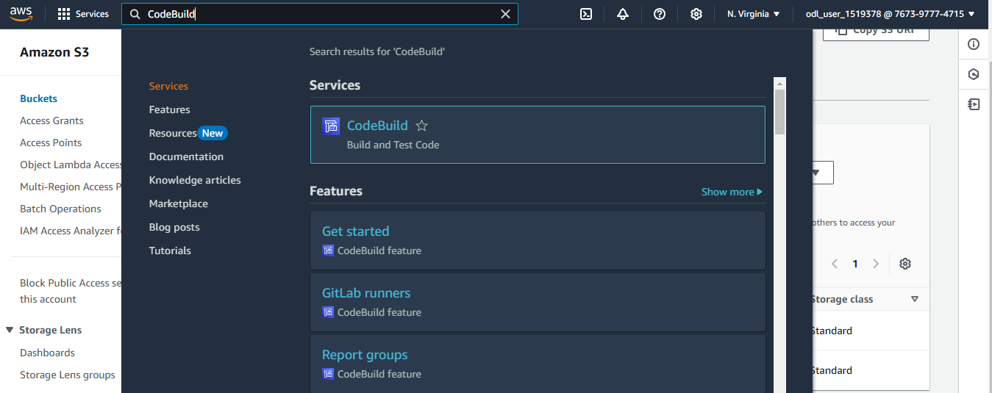
2. Click **Create project**  
     
   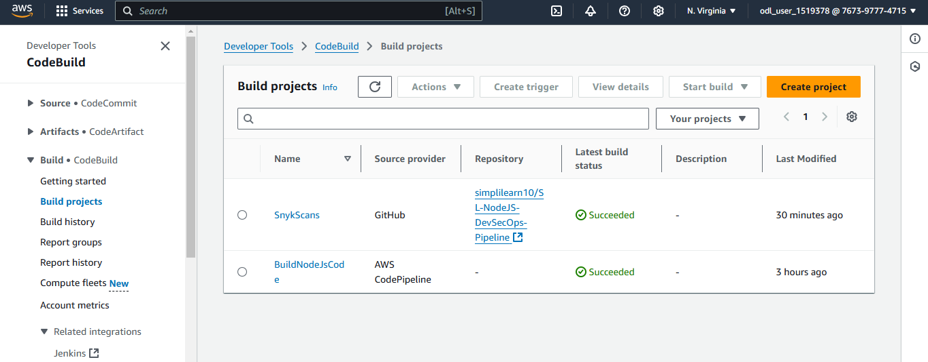
3. Give a name to the project  
     
   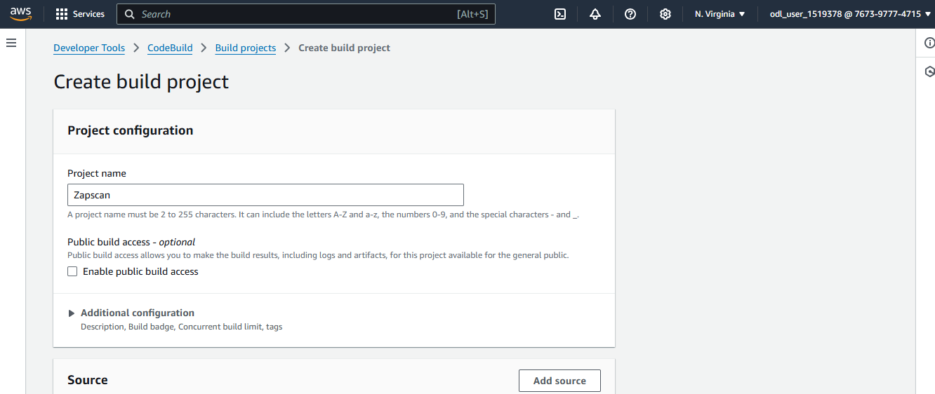
4. Choose **GitHub** as the Source provider  
     
   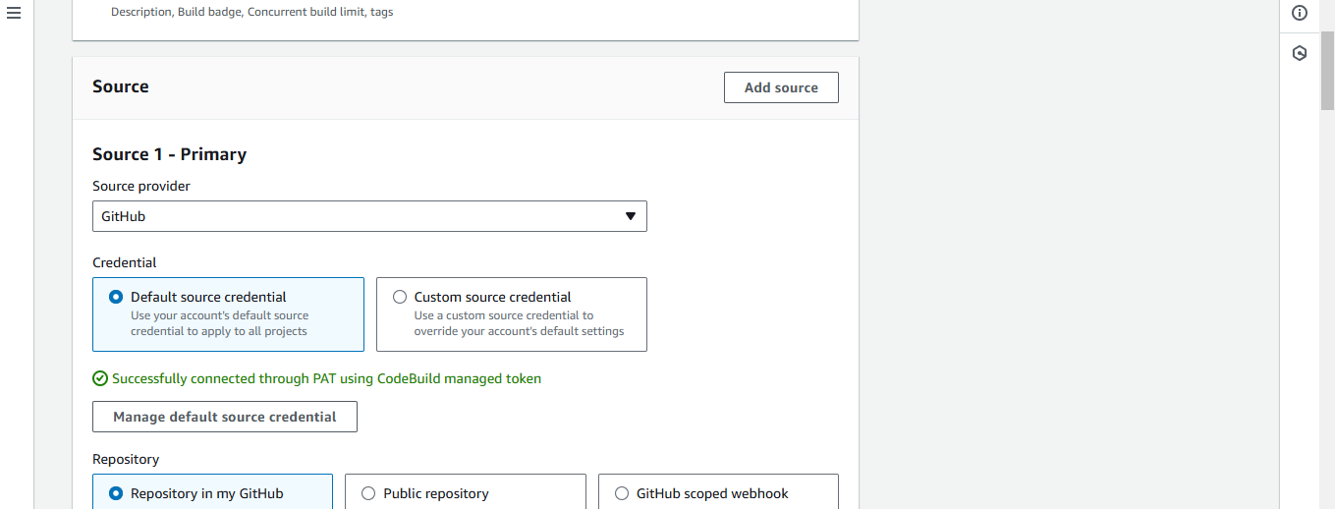
5. Navigate to your GitHub account and copy the repository link  
     
   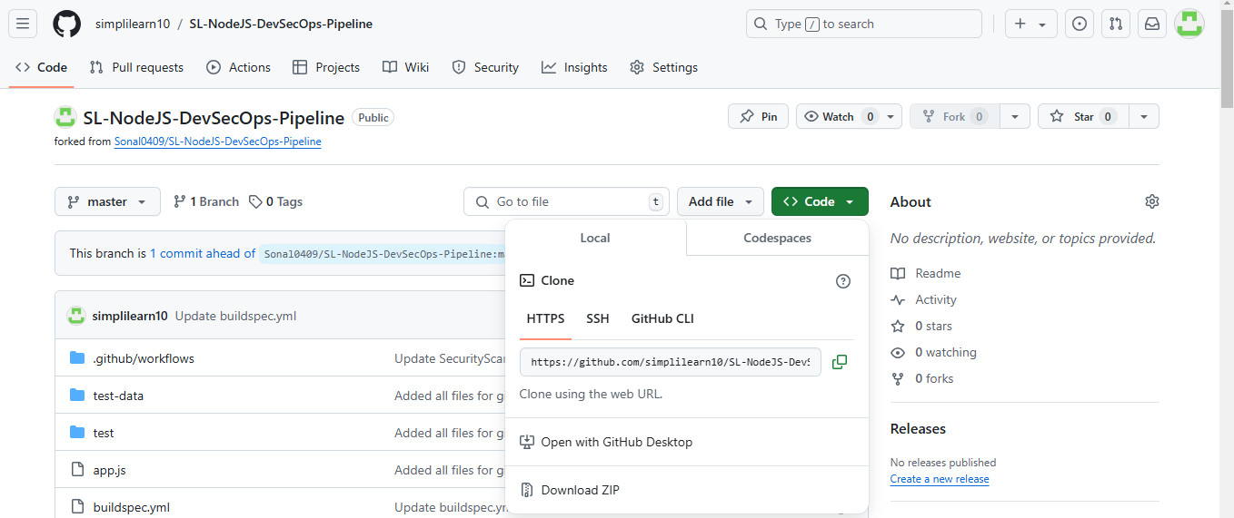
6. Paste the repository link   
     
   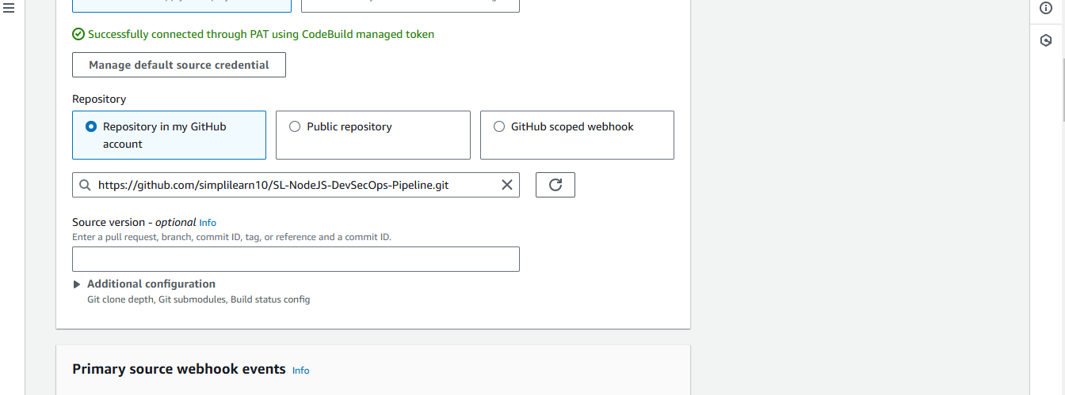
7. Choose **Use a buildspec** **file**  
     
   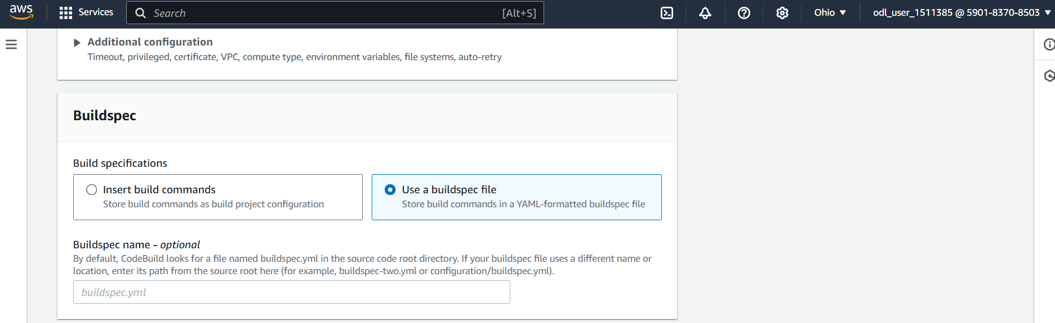
8. Choose **Amazon S3** as a type under Artifact 1  
     
   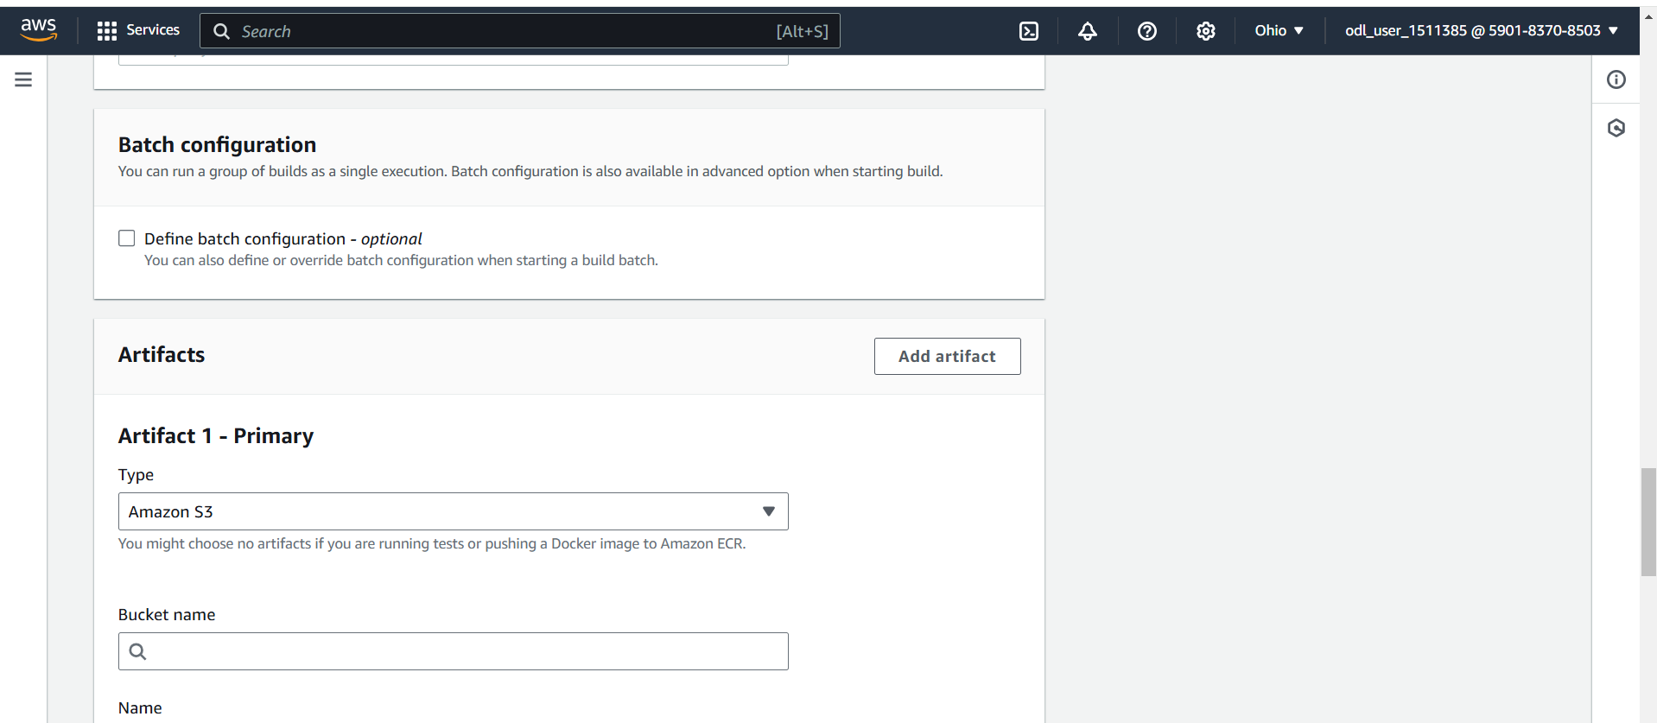
9. Choose the Bucket name   
     
   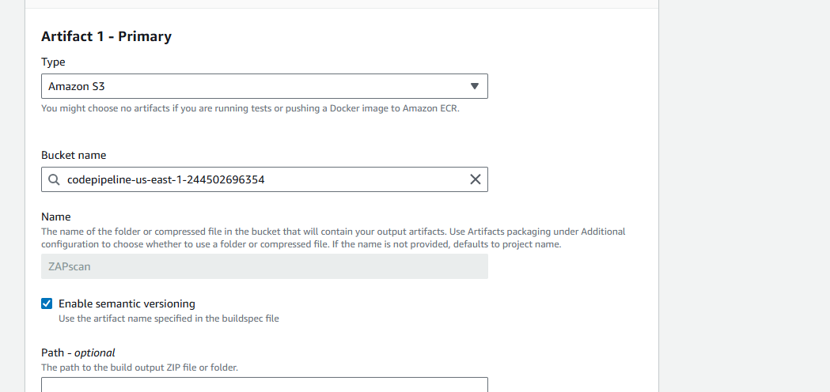
10. Scroll down and click **Create build project**  
      
    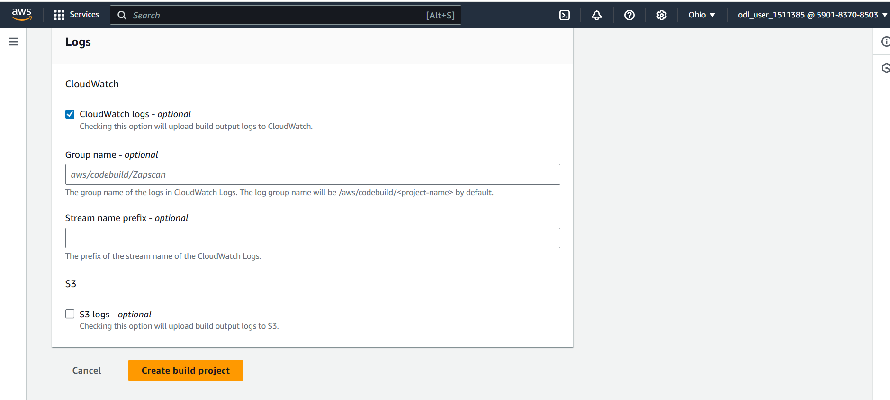
11. Click **Start build**  
      
    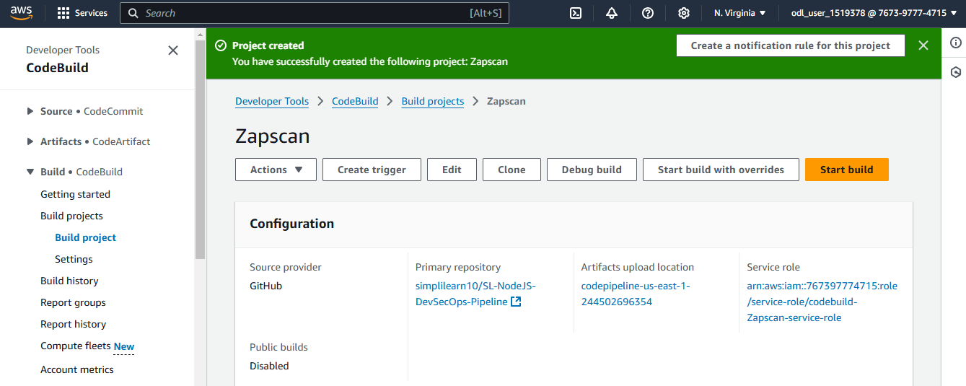

Confirm if the build is successful  
  
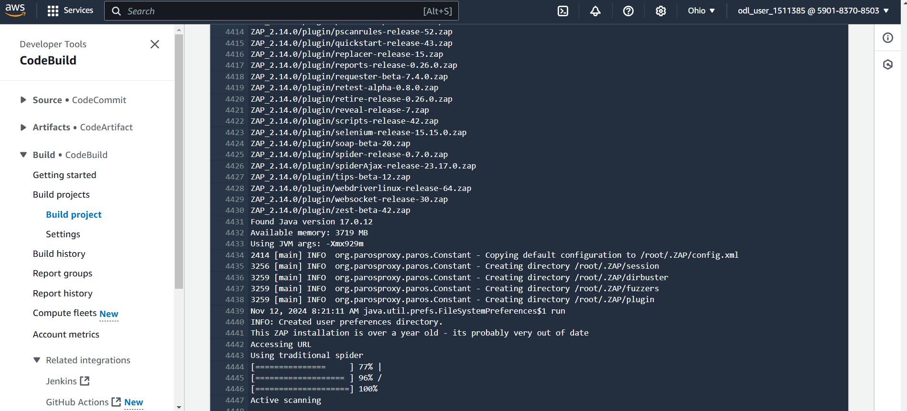  
   
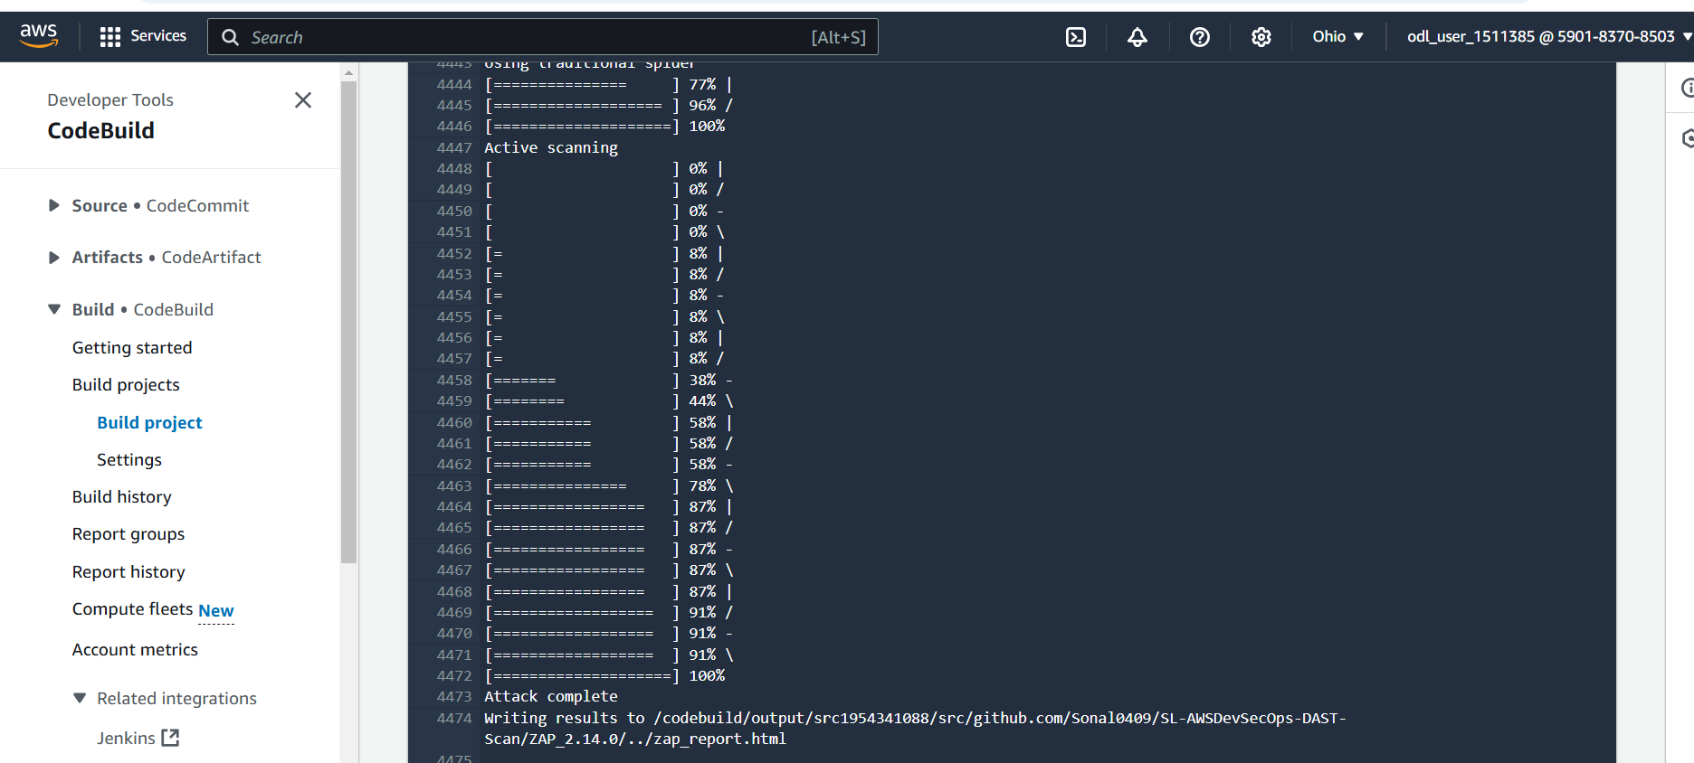

**Step 10: Monitor and validate the deployment**

1. Search CodePipeline and click on the service  
     
   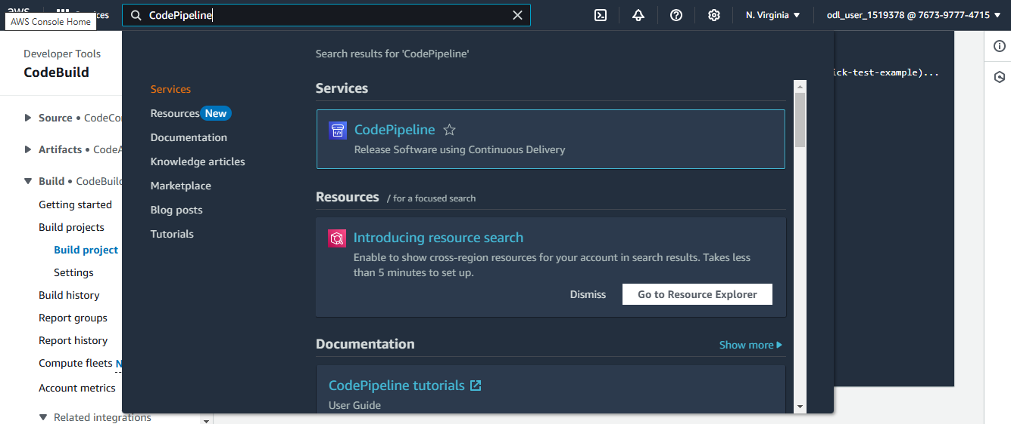
2. Click on the created pipeline  
     
   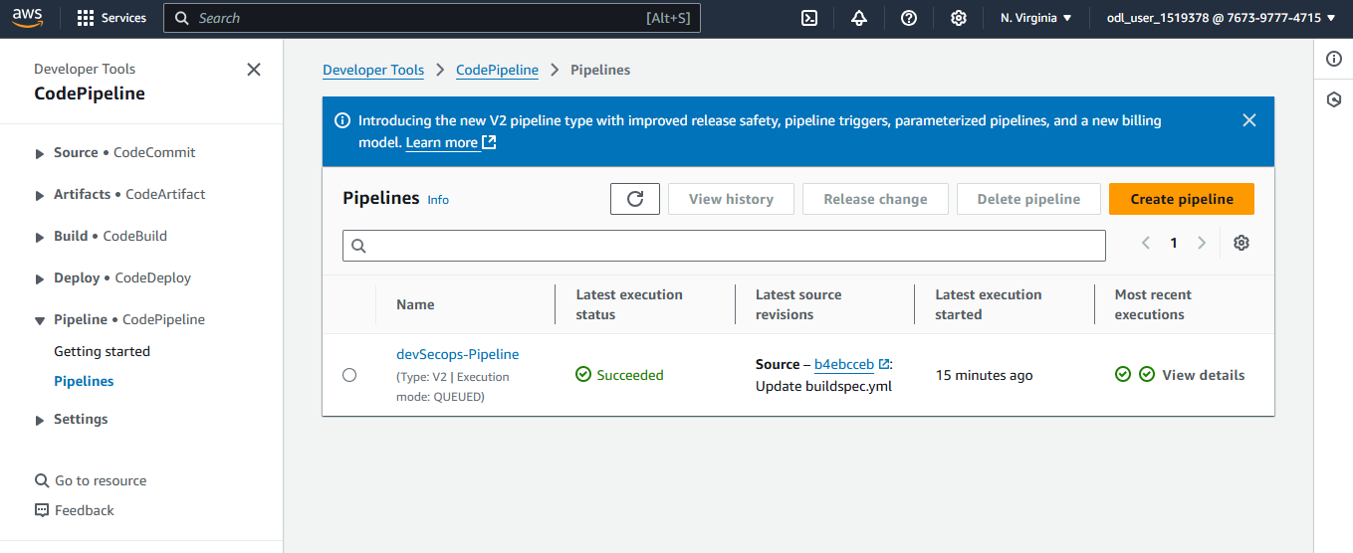
3. Scroll down and click **Add stage**  
     
   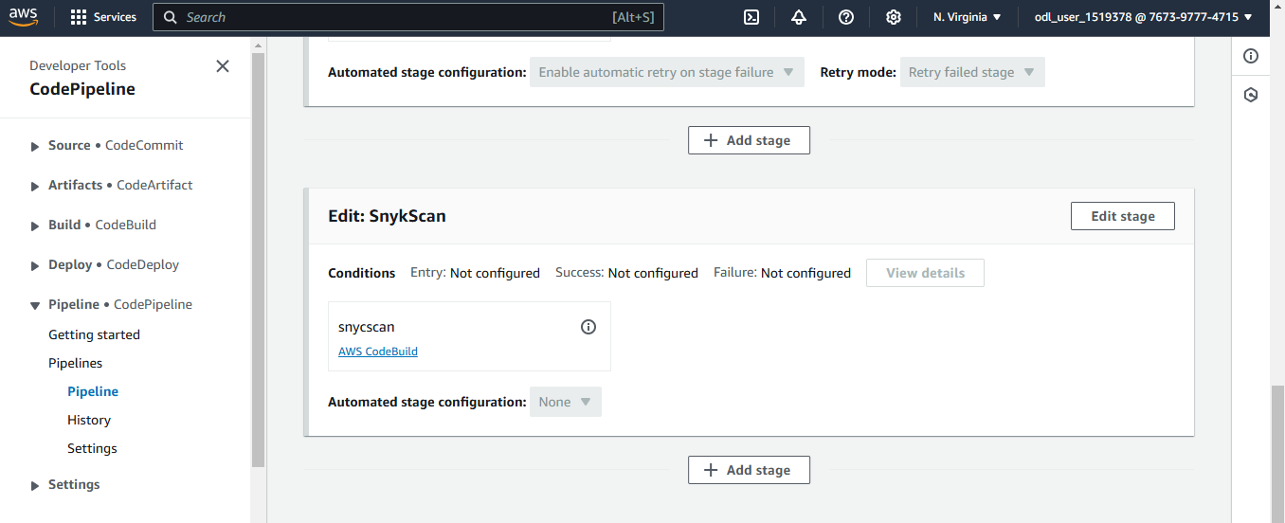
4. Give a name to the stage and click **Add stage**  
     
   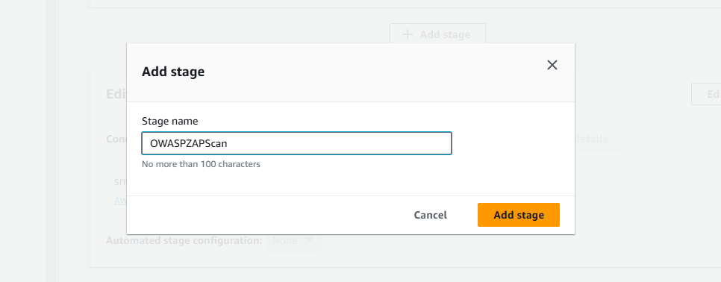
5. Click **Add action group**  
     
   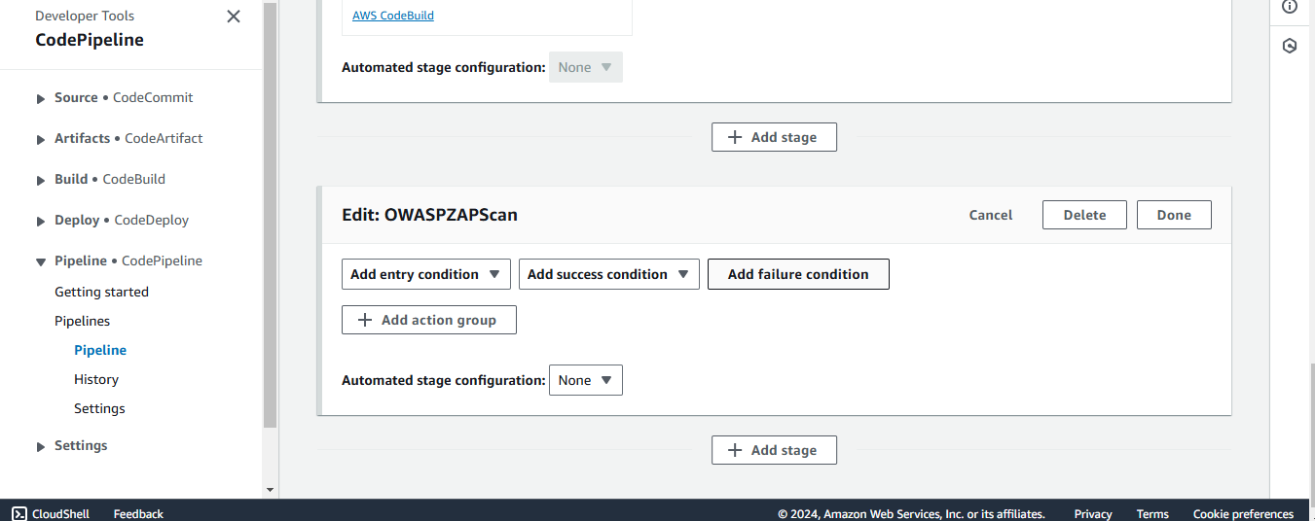
6. Provide a name to the action and choose **AWS CodeBuild** as the Action provider  
     
   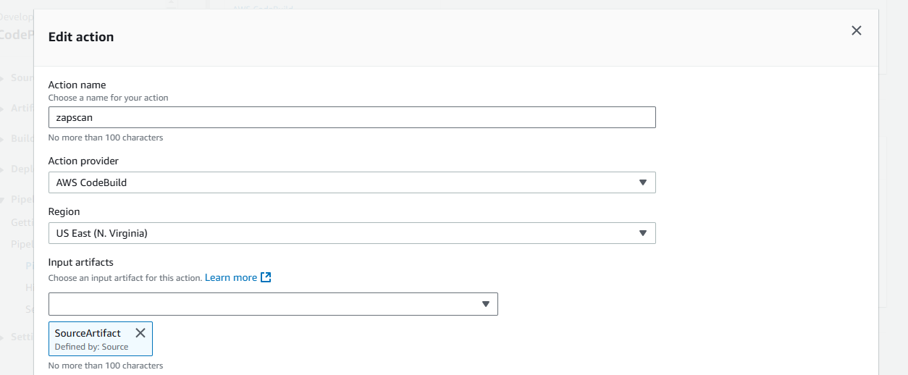
7. Choose the project   
     
   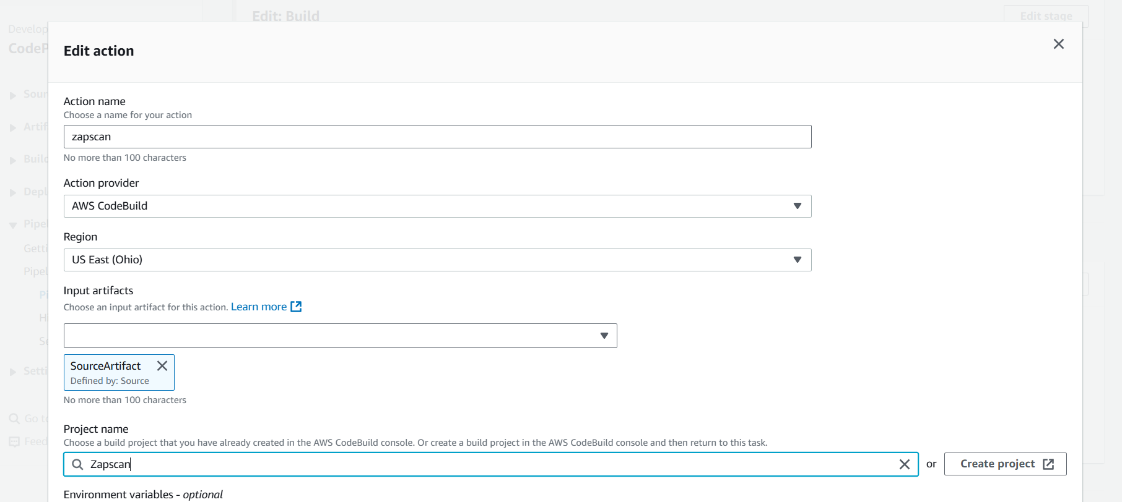
8. Scroll down and click **Done**   
     
   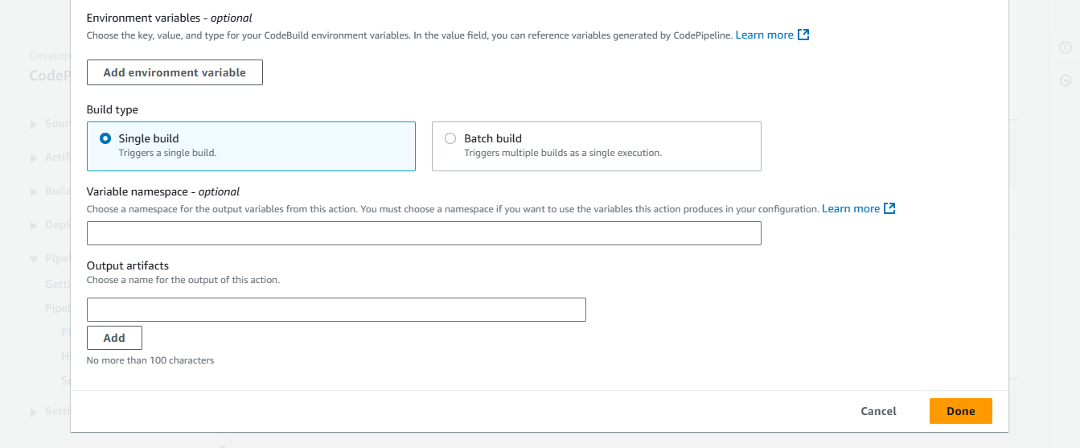
9. Scroll up and click on **Save**  
     
   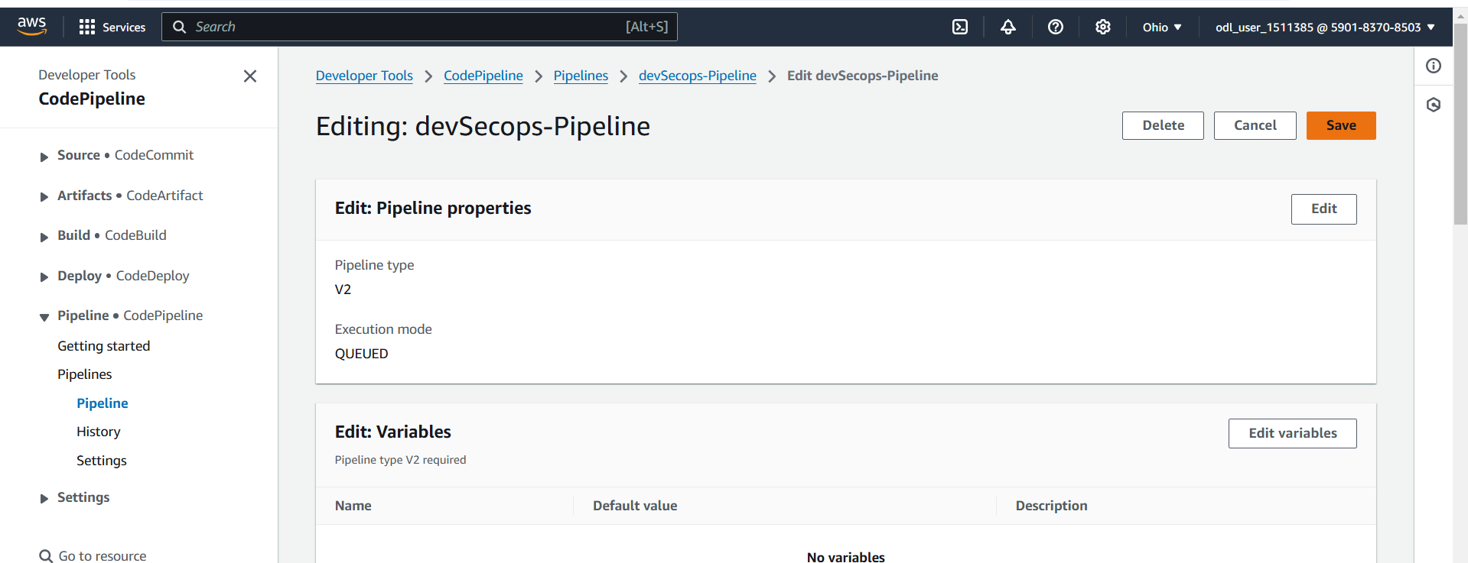
10. Click **Release change**   
      
    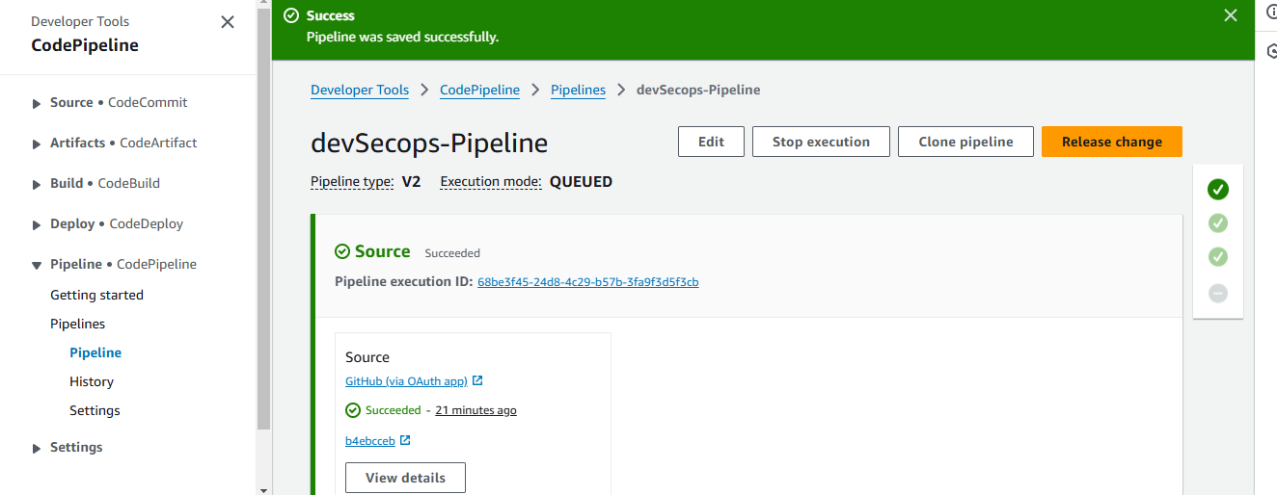

Confirm the successful creation of CodeBuild  
  
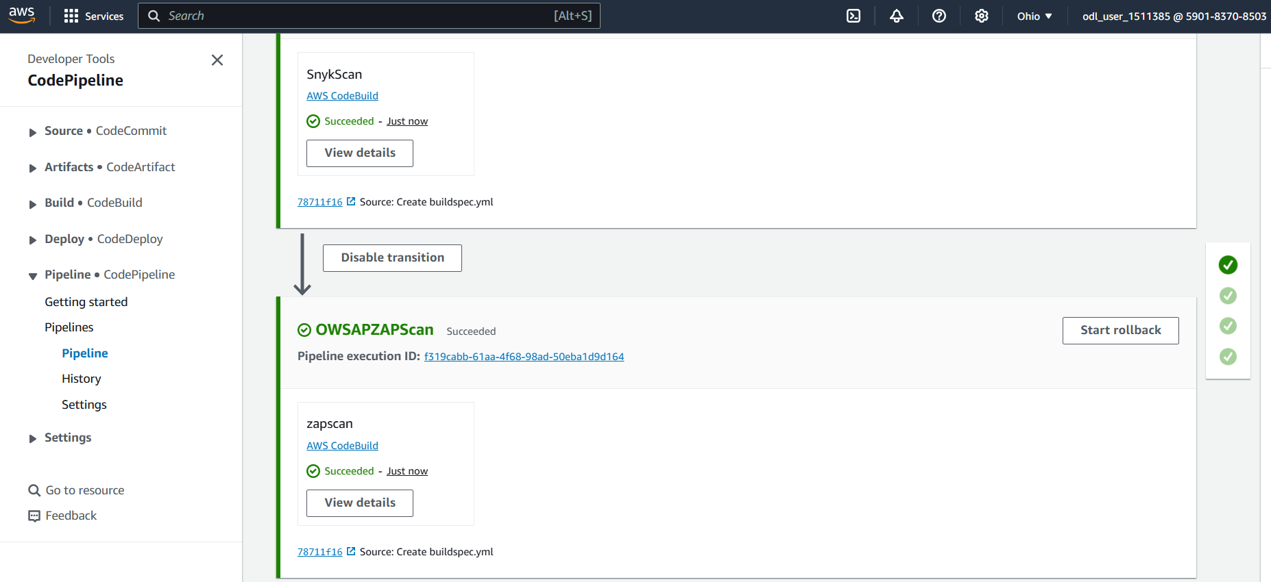

1. Review the deployment reports stored in Amazon S3  
     
   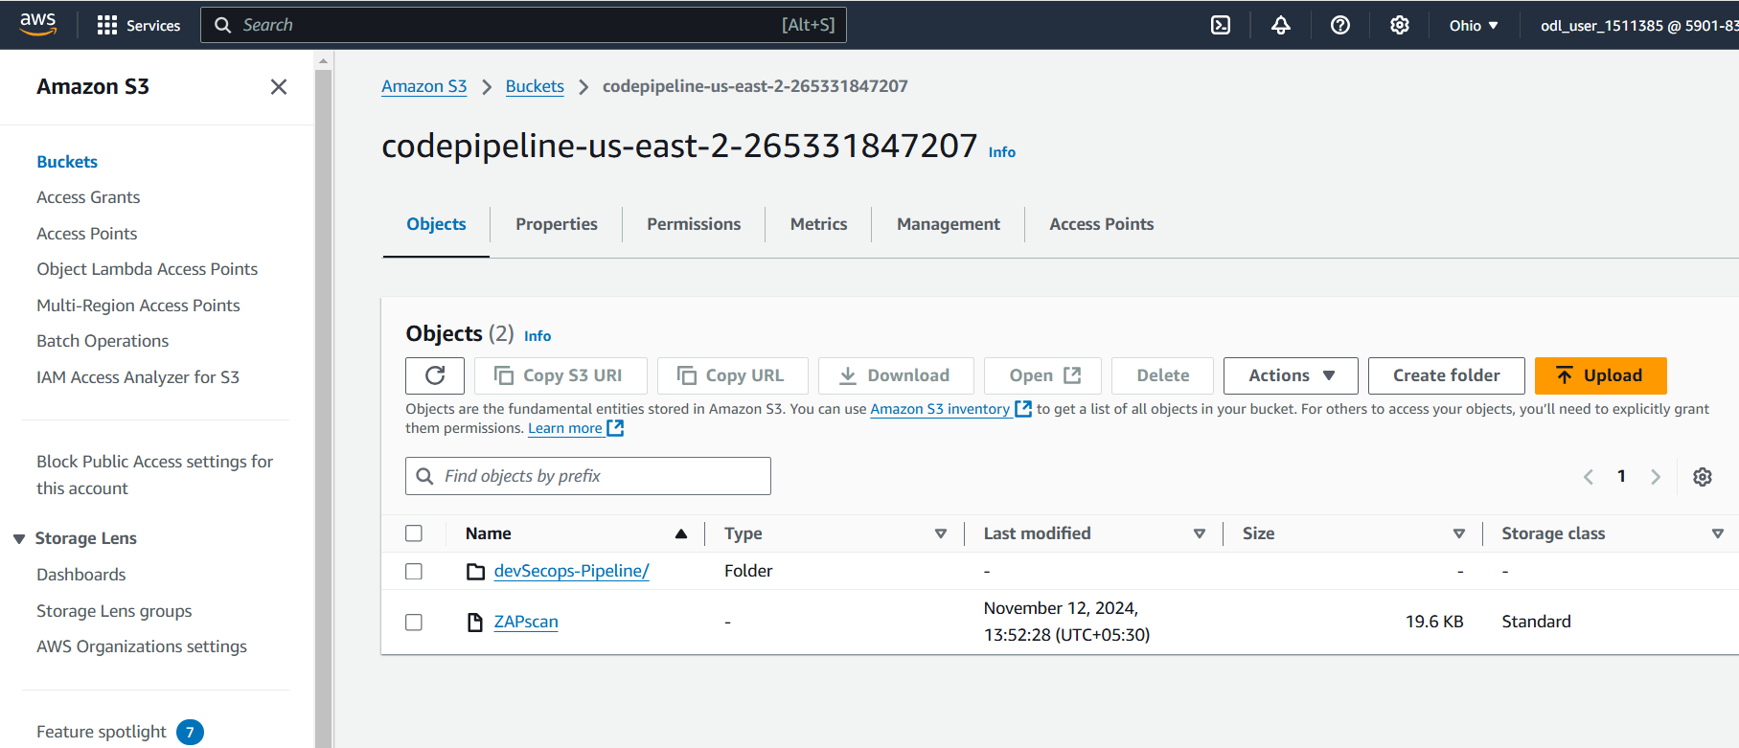  
     
   By following the above steps, you have successfully set up a secure NodeJS application pipeline using AWS CodePipeline, integrated Snyk for vulnerability scanning, and implemented SCA, SAST, and DAST scans.